ITSM Process Description
Service Catalog Management

Contents
Introduction
Service Catalog Management Process Goals and Objectives
Scope
Benefits
Key Terms and Definitions
Roles and Responsibilities
Service Catalog Management Process Owner
Service Catalog Manager
Service Owner
Service Catalog Stakeholders
Service Customer
Service Catalog High Level Process Flow
Service Catalog High Level Process Descriptions
Service Catalog Review Process Flow
Service Catalog Review Process Activity Descriptions
Service Catalog Review Process RACI Matrix
Service Catalog Maintenance Process Flow
Service Catalog Maintenance Process Activity Descriptions
Service Catalog Maintenance Process RACI Matrix
Obtain and Publish Service Information Process Flow
Obtain and Publish Service Information Process Activity Descriptions
Obtain and Publish Service Information Process RACI Matrix
Process Performance Reports
Senior Management Report
Service Owners Report
Critical Success Factors and Key Performance Indicators

Introduction

The purpose of this document is to describe the Office of Information Technology’s (OIT) Service Catalog Management Process.

Service Catalog Management Process Goals and Objectives

The goal of the Service Catalog Management Process is to ensure that the Service Catalog is produced and maintained, containing accurate information on all operational services.

To achieve this goal OIT aims to pursue the following objectives:
- Manage the information contained within the Service Catalog
- Ensure the Service Catalog is accurate and reflects the current details, status, interfaces and dependencies of all service that are available
- Provide effective information for customer engagement with the service provider
- Provide a link to standard Service Level Agreements

Scope

The scope of the Service Catalog Management Process is to provide and maintain accurate information on all services offered by OIT. Processes, external to Service Management Process, which add, change or remove a service will provide the requested changes in a timely manner.

The Service Catalog Management activities will include:
- Acquire the service definition and other information about the service from the Service Owner
- Publish Service Catalog standards and coordinate approval of standards
- Production and maintenance of an accurate Service Catalog
All Service Catalog Management activities should be implemented in full, operated as implemented and measured and improved as necessary.

Benefits

There are several benefits that can be achieved for the both the Service Providers and the customers by implementing an effective and efficient Service Catalog Management process. The Service Catalog Management Project Team has agreed that the following benefits are important to OIT and will be assessed through continuous process improvement throughout the Service Catalog Management process lifecycle:
- IT Services are clearly described to customers and service engagement methods are detailed for customers
- Provides a reliable information channel with customers, relieving IT support personnel from ad hoc information requests
- Future services are communicated in one central location using one medium
- IT service details are maintained in one central location
- When linked to request fulfillment, the Service Catalog can be a portal for customer service requests for orderable services
- Reinforces the service culture

Key Terms and Definitions

Business Unit: A segment of the Business which has its own plans, metrics, income and costs. Each Business Unit owns Assets and uses these to create value for Customers in the form of goods and Services.

Customer: Someone who buys goods or Services. The Customer of an IT Service provider, usually from the Business Unit, is the person or group who defines and agrees the service level targets.

User: Someone who uses the IT service on a day-to-day basis. Sometimes mistakenly referred to as the customer.

Functional Unit: A team or group of people and the tools they use to carry out one of more processes or activities; for example, the Service Desk.

IT Service: A Service is a means of delivering value to Customers by facilitating outcomes Customers want to achieve without the ownership of specific costs and risks. An IT Service uses Information Technology to support the Customer’s business processes.

Service Provider: An organization which supplies Services to one or more customers. A Service Provider is often used as an abbreviation for IT Service Provider.

Operational Level Agreement (OLA): An Agreement between an IT Service provider and another part of the same organization. An OLA supports the IT Service provider’s delivery of IT Services to Customers. The OLA defines the goods or Services to be provided and the responsibilities of both parties.

Service Catalog: The Service Catalog is a database or structured document with information about all Live IT Services including those available for Deployment. The Service Catalog is the only part of the Service Portfolio published to Customers and is used to support the sale and delivery of IT Services. The Service Catalog includes information about deliverables, prices, contact points, ordering and request processes. The Service Catalog contains information about two types of IT Service: Customer-facing services that are visible to the business; and supporting services required by the service provider to deliver customer-facing services.

Service Level: A Service Level is a measured and reported achievement against one or more Service Level Targets. The term Service Level is sometimes used informally to mean service level target.

Service Level Agreement (SLA): A SLA is an agreement between an IT Service Provider and a Customer. The SLA describes the IT Service, documents service level targets, and specifies the responsibilities of the IT Service provider and the Customer. A single SLA may cover multiple IT Services or multiple Customers.

Service Portfolio: This is the complete set of Services that are managed by a Service Provider. The Service Portfolio is used to manage the entire lifecycle of all Services and includes three categories: Service Pipeline (proposed or in Development), Service Catalog (Live or available for Deployment), and Retired Services.

Underpinning Contract (UC): A contract between an IT Service Provider and a Third Party. The Third Party provides goods or Services that support delivery of an IT Service to a Customer. The Underpinning Contract defines targets and responsibilities that are required to meet agreed Service Level Targets in an SLA.

Roles and Responsibilities

A role refers to a set of connected behaviors or actions that are performed by a person, team or group in a specific context. Process roles are defined by the set of responsibilities, activities and authorities granted to the designated person, team or group.

Some process roles may be full-time jobs while others are a portion of a job. One person or team may have multiple roles across multiple processes. Caution is given to combining roles for a person, team or group where separation of duties is required. For example, there is a conflict of interest when a software developer is also the independent tester for his or her own work.

Regardless of the scope, role responsibilities should be agreed by line management and incorporated into existing job descriptions and/or included in yearly objectives. Once roles are assigned the assignees must be empowered to execute the role activities and given the appropriate authority for holding other people accountable.

All roles and designated person(s), team(s), or group(s) should be clearly communicated across the organization. This should encourage or improve collaboration and cooperation for cross-functional process activities.

Service Catalog Management Process Owner

Profile | The person fulfilling this role is responsible for ensuring that the process is being performed according to the agreed and documented process and is meeting the aims of the process definition. There will be one Service Catalog Management Process Owner.
Responsibilities | - Facilitate the process design  - Document and publicize the process  - Define appropriate standards to be employed throughout the process  - Define Key Performance Indicators (KPIs) to evaluate the effectiveness and efficiency of the process and design reporting specification  - Ensure that quality reports are produced, distributed and utilized  - Review KPIs and take action required following the analysis  - Address any issues with the running of the process  - Review opportunities for process enhancements and for improving the efficiency and effectiveness of the process  - Ensure that all relevant staff have the required technical and business understanding; and process knowledge, training and understanding and are aware of their role in the process  - Ensure that the process, roles, responsibilities and documentation are regularly reviewed and audited  - Interface with the line management, ensuring that the process receives the needed staff resources  - Communicate process information or changes as appropriate to ensure awareness  - Review integration issues between the various processes  - Integrate the process into the line organization  - Promote the Service Management vision to top-level/ senior management  - Function as a point of escalation when required  - Ensure that there is optimal fit between people, process, technology/tool and steering  - Ensure that the Service Catalog Management process is fit for purpose  - Coordinate and facilitate Service Catalog Management meetings to assess Service Catalog quality and value and to address any actionable gaps
Authority | - To escalate any breaches of the Service Catalog Management Process to higher management levels  - To take remedial action as a result of any process non-compliance  - To approve proposed changes to the Service Catalog Management Process  - To initiate research into changing tooling; however, the tool owner is responsible for the tool and will have the final say  - To organize training for IT employees and nominate staff for training.  - To escalate to line management remedial training needs  - To negotiate with the relevant Process Owner if there is a conflict between processes  - To ensure that the Service Catalog meets Customer and Service Provider requirements

Service Catalog Manager

Profile | Performs the day-to-day operational and managerial tasks demanded by the process activities.
Responsibilities | - Ensure that the Service Catalog is available, accurate, and meets IT Service Provider and End User needs  - Obtain and verify information to be included in the Service Catalog from the authorized Service Owners and other information providers  - Obtain End User satisfaction feedback  - Assist with the production and maintenance of an accurate links to Service Level Agreements, Operating Level Agreements, Underpinning Contracts, the Service Portfolio, and the corresponding maintenance procedures  - Ensure that Service Catalog assessment reviews are scheduled, carried out with customers regularly and are documented with agreed actions  - Ensure that improvement initiatives identified in Service Catalog reviews are acted upon and progress reports are provided to customers  - Ensure each service has an identified Service Owner and Provider  - Record and manage all complaints and escalate, where necessary, to reach resolution  - Provide measurement, recording, analysis and improvement options and recommendations  - Analyze and review Service Catalog and SLM agreements for referential integrity, and to ensure that the catalog and agreements take into account the same service dependencies  - Organize and maintain the regular Service Catalog review activities with both Customers and IT Providers including:  - Review outstanding actions from previous reviews  - Review recent performance and availability  - Review Service Catalog Service Levels and Targets, as necessary  - Review associated underpinning agreements and OLAs as necessary  - Agree on appropriate actions to maintain / improve Service Catalog Service Levels  - Initiate any actions required to maintain or improve Service Catalog Service Levels  - Attend Change Advisory Board meetings when appropriate  - Identify opportunities for improving the tools used  - Identify improvement opportunities to make the Service Catalog Management process more effective and efficient  - Audit the Service Catalog Management process  - Escalate to the Service Catalog Management Process Owner where the process is not fit-for-purpose  - Promote the Service Catalog and SCM within the organization, through available communication channels and training SCM staff in communication skills where needed
Authority | - To approve content to be published in the Service Catalog  - To escalate Service Catalog Service Level Agreement breaches to line management (directly to section managers, where applicable) and process management  - To escalate to line management and the Service Catalog Management Process Owner in case of a conflict between process and line management. Escalation reports are sent to the Process Owners and line management  - To report on all changes to the Service Catalog  - To recommend service improvements and initiate approved Service Improvement Programs

Service Owner

Profile | Is accountable for the availability, performance, quality, and cost of one or more services. Deals directly with the Service Customer or proxy, usually in the context of a Service Level Agreement, Operating Level Agreement, or an Underpinning Contract. Uses the Service Catalog to set User and Service Customer expectations. Service Manager is responsible for day-to-day operation of the service.
Responsibilities | - Define the definition of the service, service attributes and service engagement methods  - Provide detailed service information to Service Catalog Manager for inclusion in Service Catalog  - Produce and maintain Service Level Agreements, Operating Level Agreements and Underpinning Contracts  - Ensure service level monitoring is in place to support the agreed upon service levels  - Produce, review and evaluate reports on service/system performance, achievements and breaches for the service level manager and Customer  - Perform annual Service Catalog reviews as initiated by the Service Catalog Manager  - Work with Service Level Manager to provide services and service levels to meet the customers requirements  - Coordinate and manage activities to improve service levels  - Attend top-level management meetings to assess and represent the Service Level Requirements balanced with the relative cost

Service Catalog Stakeholders

Profile | Are knowledgeable about the Service Catalog Management Process. Can be either Service Providers, Service Owners, IT Support Staff, or Service Customers.
Responsibilities | - Participate as a group in the governance of the Service Catalog and the Service Catalog Management Process
Authority | - Recommend Service Catalog Management Policy

Service Customer

Profile | May be the payer for a service on behalf of Users that actually use the service. The payment may be direct or indirect. May deal directly with the Service Provider/Owner, usually in the context of a Service Level Agreement, Operating Level Agreement, or an Underpinning Contract. Uses the Service Catalog to select Services, Service features, estimate costs, understand IT Service relationships.

CITO Staff

Responsibilities | - Approve changes to the Service Catalog as requested by the Service Catalog Manager  - Approve changes to the Service Catalog Process as requested by the Service Catalog Process Owner

Service Catalog High Level Process Flow

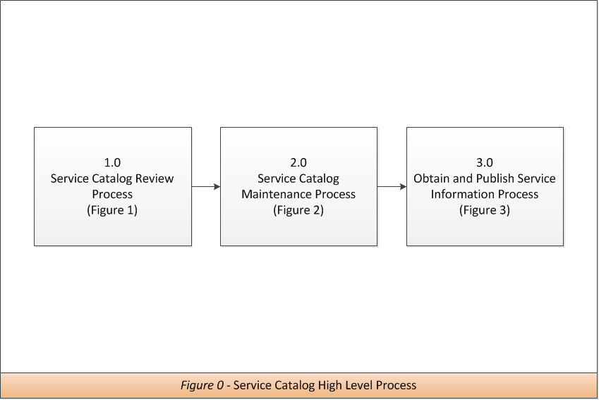

Service Catalog High Level Process Descriptions

Activity | Description
1.0  Service Catalog Review | Recurring periodic reviews are used to assure Service Catalog accuracy and alignment with customer service needs. Service Catalog Process KPIs are used to measure progress against the CSFs.
2.0  Service Catalog Maintenance | Input is from the periodic Service Catalog Reviews and quality issues reported via the Incident Management process. This process maintains current and accurate information within the Service Catalog.
3.0  Obtain and Publish Service Information | The information gathered for a Service Catalog entry constitutes the public declaration of the service definition and many important attributes of the service. For new services this information may be available from the Service Design Package. For existing services the information may be gathered from authorized sources such as the Service Owner and/or third party Service Provider.

Service Catalog Review Process Flow

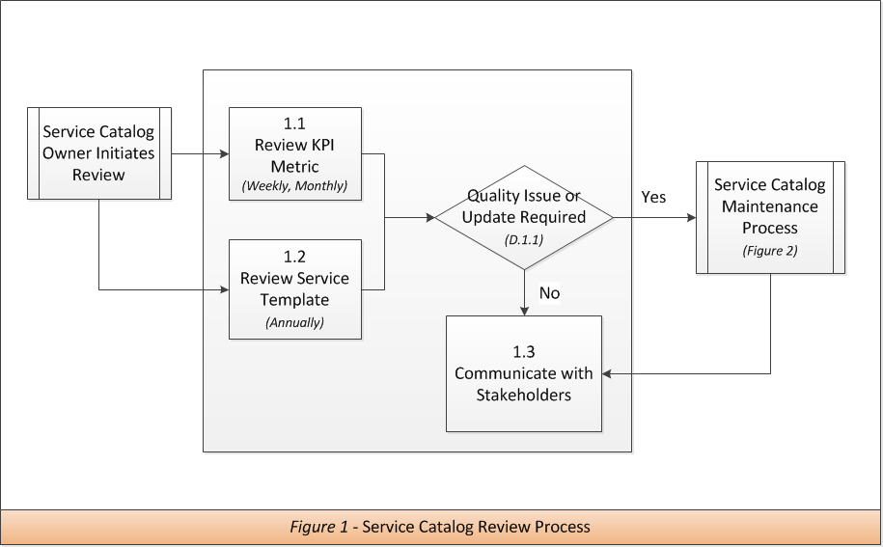

Service Catalog Review Process Activity Descriptions

1.1 | Review KPI Metrics
Purpose | Measure progress toward achieving Critical Success Factors
Guiding Principle | Continual Service Improvement will be used to ensure high level of service.
Inputs | KPI Metrics and reports
Procedure or Work Instruction Steps | - Periodically (weekly, monthly, annually) review generated reports and metrics  - Identify quality issues or areas of improvement  - Log/record results  - Report issue via Service Catalog Maintenance Process
Outputs | Review summary
Metric | - Metrics delivered on time  - Positive vs. negative KPI trends

1.2 | Review Service Template
Purpose | Digest the results of the applicable review
Guiding Principle | At a minimum, each service in the Service Catalog will be reviewed annually
Inputs | Service Review Template submitted by Service Owner
Procedure or Work Instruction Steps | - Upon receipt of service review template  - Service Catalog Process Owner / Manager will identify suggested changes  - Report issue via Service Catalog Maintenance Process
Outputs | Review Summary
Metric | Number of service reviews completed on time

D.1.1 | Quality Issue or Update Required
Purpose | Based upon review of the KPI metrics and templates, all quality issues will be forwarded through the Service Catalog Maintenance Process. Stakeholders will be kept informed annually or as needed.

1.3 | Communicate with Stakeholders
Purpose | Provide transparent communication with all stakeholders
Guiding Principle | Stakeholders will be kept informed about changes to the services within the Service Catalog and process performance on no less than an annual basis
Inputs | Review summaries
Procedure or Work Instruction Steps | Provide executive summary to stakeholders as required
Outputs | Executive summary, Stakeholder updates
Metric | N/A

Service Catalog Review Process RACI Matrix

Activity | SC Process Owner / Manager | Service Owner / Provider | Service Customer | Stakeholder | CITO Staff
1.1  Review KPI Metrics | A,R | C
1.2  Review Service Template | A,R | C
D.1.1  Quality Issue or Update Required Decision | A,R | C
1.3  Communicate with Stakeholders | A,R | C |  | I | I

Service Catalog Maintenance Process Flow

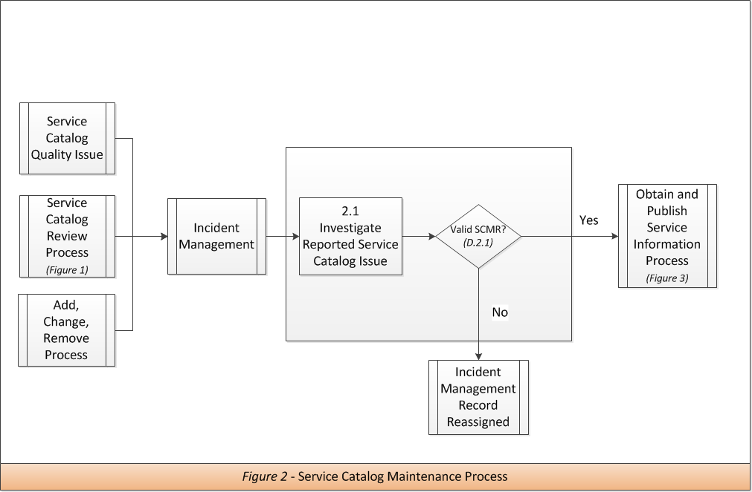

Service Catalog Maintenance Process Activity Descriptions

2.1 | Investigate Reported Service Catalog Issue
Purpose | Initial troubleshooting and validation to determine if ticket is related to Service Catalog
Guiding Principle | Incorrectly assigned requests will be reassigned to correct department.
Inputs | Service Catalog Maintenance Request (SCMR). This will come in the form of an incident, problem or change record submitted through OIT’s ITSM tool.
Procedure or Work Instruction Steps | - Upon receipt of SCMR  - Review reported issue to determine relevance to Service Catalog  - Perform initial troubleshooting to determine if issue resides within Service Catalog  - Update SCMR
Outputs | Updated SCMR
Metric | Number of SCMRs incorrectly assigned

D.2.1 | Valid SCMR
Purpose | Determine whether service catalog maintenance issue resides within the Service Catalog or a supporting service. If issue resides within supporting service, request will be reassigned.

Service Catalog Maintenance Process RACI Matrix

Activity | SC Process Owner / Manager | Service Owner / Provider | Service  Customer | Stakeholder | CITO Staff
2.1  Investigate Reported Service Catalog Issue | A/R | C | I | I
D.2.1  Valid SCMR Decision | A/R | I | I | I

Obtain and Publish Service Information Process Flow

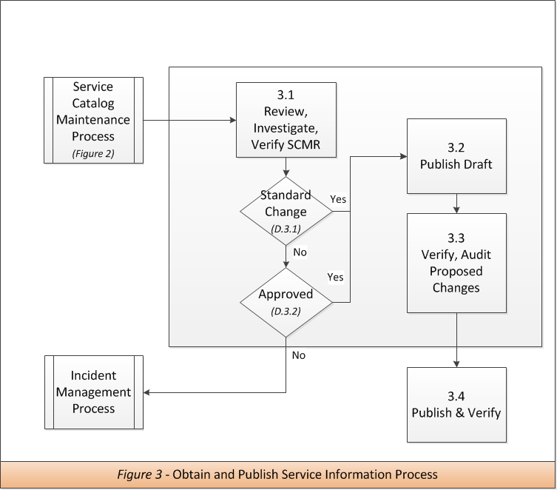

Obtain and Publish Service Information Process Activity Descriptions

3.1 | Review, Investigate, Verify SCMR
Purpose | Validate request for relevance, accuracy and completeness
Guiding Principle | All changes to the service catalog will be reviewed by the SC owner. Additional approval by the CITO Staff will be sought for new/retired services and non-standard changes.
Inputs | Incident or Change request
Procedure or Work Instruction Steps | - Verify SCMR is complete  - Determine validity/relevance of request  - If required, coordinate corrections with submitter  - Update request in ITSM tool
Outputs | Validated SCMR
Metric | - Number of requests submitted  - Number requested rejected  - Number of requests accepted  - Number of requests per service

D.3.1 | Standard Change
Purpose | Determine whether the SCMR meets the requirements for a standard change.

D.3.2 | Approved
Purpose | If SCMR does not meet the requirements for a standard change, the request may need approval from the the CITO Staff. If no approval is given, the SCMR is routed back through the Incident Management process to determine next steps.

3.2 | Publish Draft
Purpose | Apply validated SCMR to the Service Catalog in Test until approved.
Guiding Principle | The Service Catalog Manager is responsible for posting Service Catalog Maintenance Request records to the Service Catalog Database.  Changes to the Service Catalog database will be applied in Test pending approval.
Inputs | Validated SCMR
Procedure or Work Instruction Steps | - Enter or update all relevant information in Test  - Notify stakeholders of changes and set review deadline  - Update SCMR
Outputs | Updated Service Catalog Database in test, Stakeholder Notification
Metric | N/A

3.3 | Verify, Audit Proposed Changes
Purpose | Obtain validation/approval from all stakeholders prior to applying changes to production
Guiding Principle | The Service Catalog Manager is responsible for the transparent review and approval of all changes to the Service Catalog
Inputs | Updated Service Catalog Database in test
Procedure or Work Instruction Steps | - Stakeholders will review changes per area of responsibility  - Service Catalog Database  - HPSM categories  - Roxen style guide  - Portfolio  - Other areas may include SLM, SCM  - Required corrections are made to Service Catalog  - Update SCMR
Outputs | Updated Service Catalog Database, Stakeholder notification
Metric | - Reviews completed within deadline

3.4 | Publish & Verify
Purpose | Finalize all released changes
Guiding Principle | Only reviewed and approved changes are moved to Production
Inputs | Stakeholder input reviewed in Test
Procedure or Work Instruction Steps | - Upon receipt of required reviews and approvals  - Move all changes from Test to Production  - Verify Changes in Production  - Notify stakeholders  - Update and close SCMR
Outputs | Updated Service Catalog Database
Metric | - Number of SCMRs closed

Obtain and Publish Service Information Process RACI Matrix

Activity | SC Process Owner / Manager | Service Owner / Provider | Service  Customer | Stakeholder | CITO Staff
3.1  Review, Investigate, Verify SCMR | A/R | C | I | I | I
3.2  Publish Draft | A/R | I | I | I | I
3.3  Verify, Audit proposed changes | A | R | I | R | I
3.4  Publish & Verify | A/R | I | I | I | I
D.3.1  Standard Change Decision | A/R | I | I | I | I
D.3.2  Approved Decision | A/R | I | I | I | I

Service Catalog Review Activities

Activity | Responsibility for Production
- For each service, gather answers to Service Catalog Review questionnaire from service owners.  - For each service, gather answers to Service Catalog Review questionnaire from service users.  - Based on input from service owners and users, compile and share list of action items.  - Implement updates, including services to be retired and/or any new services. | Service Catalog Manager

Process Performance Report
This section describes the Service Catalog Management reports as recommended for OIT management. Only an overview of the reports, including their use and objective is provided.

Annual Service Catalog Review report

The Annual Service Catalog Review Report generated for the CITO staff, Service Providers, and Service Owners. It provides summary information resulting from the Annual Review. Identifies changes and updates made to the Service Catalog

Contents | Responsibility for Production
This report is a formal document and is subject to document control. The following structure is recommended:  - Summarized Review of Service Catalog Management performance against CSFs  - Service Catalog Management issues requiring Senior Management action with a crisp description of the requested action  - Specific Critical Success Factors included in this report are identified in the Management Report / Critical Success Factor Mapping Table | Service Catalog Manager

Service Catalog Process Performance Report

This report details the performance of the Service Catalog Process. It details specific performance data at the service index level. It provides information on the quality and performance of the Service Catalog Management process and identifies areas for improvement.

Contents | Responsibility for Production
This report is a formal document and is subject to document control. The following structure is recommended:  - Management Summary  - KPI Metric Data  - Analysis of KPI Metrics  - Specific Critical Success Factors included in this report are identified in the Management Report / Critical Success Factor Mapping Table. | Service Catalog Management Process Owner
 | Frequency
 | Quarterly

Critical Success Factors and Key Performance Indicators

Numbers | CSFs | KPIs | Sources | Calculation Interval
1 | The Service Catalog is being used regularly and consistently by customers and end users
1.1 |  | Service Catalog page hits increase | Google Analytics | A) Weekly B) Monthly C) Annually
1.2 |  | General information requests at the Support Center decrease | HPSM | A) Weekly B) Monthly C) Annually
1.3 |  | The number of people authenticating to the supporting and technical sections of the Service Catalog increases | Shibboleth, CAS, various authentication methods. A script may need to be written. | A) Monthly
2 | Services that are suitable for self service and/or user orderable, are made available within the Service Catalog
2.1 |  | Number of services offered within the Service Catalog that are able to be self-service and/or user orderable increase | Bi-annual and annual Service Catalog Review | A) Annually B) Bi-annually
3 | Improvement in service offering's awareness and provisioning engagement.
3.1 |  | Traffic for services that are self-service and/or user orderable increases | Google Analytics | A) Monthly B) Annually
3.2 |  | Number of tickets opened via the support center for user orderable services decreases | HPSM | A) Monthly B) Annually
3.3 |  | The number of searches for the Service Catalog or individual services increase | Main UAF website or Google Analytics (searches for specific services) | A) Monthly B) Annually
3.4 |  | The number of people using the SC for service or information requests increases | Annual Survey | A) Annual
4 | Customers are satisfied with the Service Catalog
4.1 |  | The Service Catalog is generally the preferred resource for getting info and/or requesting service | Surveys | A) Weekly B) Monthly C) Annually
4.2 |  | End users were able to accomplish what they needed to after going to the Service Catalog | Add check box at the end of each service index allowing users to fill out a survey question, ʺWas this information helpful?ʺ (Service Catalog). If the user clicks no, that it was not helpful, then include a small comments box to capture why it was not helpful. | A) Weekly B) Monthly C) Annually
4.3 |  | End users feel the Service Catalog is easy to use. | Surveys | A) Weekly B) Monthly C) Annually
4.4 |  | Customers feel that the Service Catalog is up to date | Surveys, Roxen report showing the last time a service page was updated, date updated included within the service index | A) Weekly B) Monthly C) Annually

