

**AK EPSCoR IoC Travel Award Application Form**

**Application deadline: 5:00pm, October 24, 2025**

Please review the solicitation details at [alaska.edu/epscor/opportunities/travel-funding/](http://alaska.edu/epscor/opportunities/travel-funding/) thoroughly before applying. NOTE: All Travel should be completed by June 30, 2026. Expense reports must be submitted and paid out by July 27, 2026.

**Questions? Contact Tara Borland at taborland@alaska.edu or (907) 474-6288.**

1. **Applicant Information**

| **First and Last Name** |  |
| --- | --- |
| **Office Mailing Address** |  |
| **Phone Number** |  |
| **Email Address** |  |
| **Role (Student, Staff, Faculty, Other)** |  |
| **Primary Affiliation (Institution)** |  |
| **Institution Travel Coordinator** |  |
| **Institution Fiscal Contact** |  |
| **Institution Fiscal Contact Email Address** |  |

How did you hear about this opportunity?

**\*\*[Insert text here]\*\***

1. **Activity Information**

Please select one of the following:

* Research-related conference travel/registration (please list conference URL, destination, dates, and title of presentation in the next question)
* Knowledge exchange / Science collaboration / Community Outreach (please list destination and dates in the next question)
* Professional development related conference/workshop travel/registration (please list conference URL, destination, dates, and title of presentation in the next question)
* Science education conference travel/registration (please list conference URL, destination, date)

General activity information (destination, dates, etc; see prior question):

**\*\*[Insert text here]\*\***

How does your project, travel, or conference attendance align with the themes of the Alaska EPSCoR Interface of Change project?

(Visit <https://www.alaska.edu/epscor/projects/interface-of-change/> for more information about the project.)

**\*\*[Insert text here]\*\***

What is your career stage? (ex. undergraduate/graduate student, postdoc, assistant/associate/full faculty, early/mid/late career staff)

**\*\*[Insert text here]\*\***

How will this award assist you in your career?

**\*\*[Insert text here]\*\***

One-page description of activity (if presenting at a conference, include the conference agenda, the title and abstract of your presentation, and whether it is a poster or oral):

**\*\*[Insert text here]\*\***

1. **Funding Information**

Previous Alaska NSF EPSCoR funding, if any (please list type and date of award(s)):

**\*\*[Insert text here]\*\***

What is the total amount requested for this award? (You will be asked to provide more details in a budget justification.) The maximum award amount is $1,500.

**\*\*[Insert text here]\*\***

**Budget Justification** (please use the format provided below, can be included separately):

**BUDGET JUSTIFICATION EXAMPLE**

Travel:

Domestic: One trip is budgeted per year for travel to San Francisco, CA (placeholder, at $/ticket for airfare) for one individual to attend the annual AGU conference to meet with collaborators and present research results. Per Diem (meals/incidentals/lodging) is $228/day for San Francisco. Car rental is budgeted at $100/day (daily rate including taxes and fees). Airport shuttle service is budgeted in San Francisco at $25/trip. Ground transportation is budgeted at $100/traveler/trip for all travel locations. All airfare cost data is based on Internet research from(**list site used**).

All Per Diem is in accordance with GSA/JTR Regulations.

* M&IE is the daily rate allocated to the traveler to cover the cost of meals and incidental expenses. It is commonly referred to as "daily per diem."
* The regulatory M&IE rate for most locations is determined by the [federally listed rate](https://www.gsa.gov/travel/plan-book/per-diem-rates). The regulatory M&IE rate for **Anchorage**, **Fairbanks**, **Juneau, and** their surrounding communities **within a 50-mile radius** is set by the university president. Currently, that rate is **$80**.
* The applicable rate is determined by where the traveler is lodging. The last day is determined by the traveler's last lodging location. Single-day travel is determined by the business location. The traveler is responsible for accurately documenting provided meals during travel. Meal deductions are determined by the [GSA M&IE Breakdown](https://www.gsa.gov/travel/plan-book/per-diem-rates/mie-breakdown).
* Additional guidance can be found [here](https://www.alaska.edu/uatravel/rules/meals/meals-rate.php).

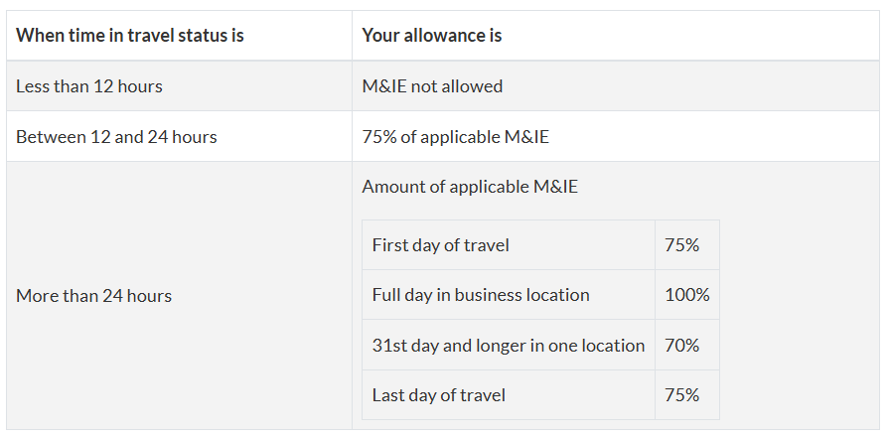

Contractual Services and Other Direct Costs:

**Registration and other fees- describe the fee and list the amount. Provide a subtotal.**

1. **Submission**

**Please submit your completed application to** [**taborland@alaska.edu**](mailto:taborland@alaska.edu)