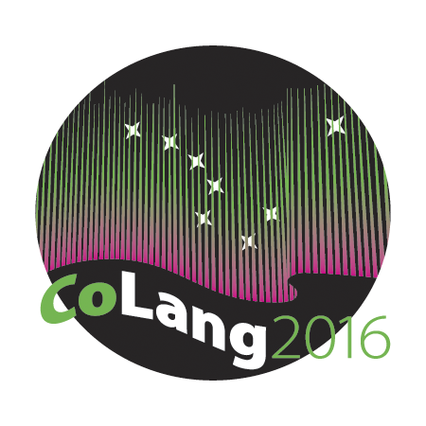

Colang 2016 Workshop Syllabus

Workshop Title: Lexicography

Instructor’s name and email: Arienne M Dwyer (anthlinguist@ku.edu)

Course materials: Participants will try out several of the tools listed under Software, below.
Supplies needed: Laptop computer.
Course goals: To learn ways of organizing and analyzing lexical materials, to make vocabulary easier to work with and share. This practical course aims to create dictionaries. It begins with an overview of general principles of dictionary types and entries and ends with software practice. Each day of this workshop is accompanied by hands-on exercises. Participants are encouraged to bring their own data (for example, word lists with glosses), and use the methods and software covered in the workshop to start producing their own dictionary.

Student learning objectives: Participants will become familiar with the theories and methods of dictionary making, including dictionary entries, and deciding which format is appropriate for a given audience. They will explore appropriate ways to gather dictionary data; get an overview of what software is available to organize, analyze, and share these lexical resources; assess the pros and cons of each for their own work, and leave the workshop having tried one or more tools on their own data, if they wish.

Instructional methods: Lecture, hands on in-class practice, discussion, and student initiated research topics.

Evaluation: Workshops will be Pass/Fail. Full attendance is required for a pass in any workshop.
Also required is a word list of at least 15 lexical items, processable by one (or more) of the tools listed below under “Software”; using another tool may be possible with prior arrangement with the instructor.

Disabilities services:
“The Office of Disability Services implements the Americans with Disabilities Act (ADA), and insures that UAF students have equal access to the campus and course materials. The instructor will work with the Office of Disabilities Services (208 WHIT, 474-5655) to provide reasonable accommodation to students with disabilities.”

Lexicography Resources

Bibliography [*Introductory / **Comprehensive / ***Community focused]

Atkins, B.T. Sue and Michael Rundell. 2008. The Oxford Guide to Practical Lexicography. Oxford University Press.**
Frawley, William, Kenneth C. Hill, and Pamela Munro. 2002. Making Dictionaries: preserving indigenous languages of the Americas. Berkeley: University of California Press.***
Hartmann, Reinhard. R. K. 2001 Teaching and Researching Lexicography. Palgrave.*
Haviland, John. 2006. Documenting lexical knowledge. In Jost Gippert, Nikolaus P. Himmelmann and Ulrike Mosel (eds.) Essentials of Language Documentation, 129-162.*/***
Jackson, Howard 2002 Lexicography: An Introduction. Routledge.*
Landau, Sidney, 2001. Dictionaries: The Art and Craft of Lexicography, 2nd ed., Oxford University Press.*
Mosel, Ulrike. 2004. Dictionary making in endangered speech communities. In: Peter K. Austin (ed.) Language documentation and description. Vol. 2, 39-54. London: SOAS.***
Svensén, Bo. 2009. A Handbook of Lexicography. The Theory and Prectice of Dictionary-Making. Cambridge University Press.**

Software

Software for Dictionary-making (*free)

*Kirrkirr (PC/Linux/Mac) http://www-nlp.stanford.edu/kirrkirr/
*Lexique Pro (PC only) http://www.lexiquepro.com
*Toolbox (PC only) http://www.sil.org/computing/toolbox/
*FLeX (PC/Linux only) http://fieldworks.sil.org/flex/
*WeSay (PC/Linux) http://wesay.palaso.org
*WOLF (PC/Linux/Mac) http://webpages.sou.edu/~harveyd/wolf/index.php

TshwaneLex (PC/Mac) http://tshwanedje.com
Miromaa (PC + Mac app) http://www.miromaa.com.au/ (see other workshop)

Software for Concordancing:

*TextStat (PC only) http://neon.niederlandistik.fu-berlin.de/en/textstat/
*AntConc (Mac/PC/Linux) http://www.laurenceanthony.net/software.html

N.B.: “PC only” software might be cajoled to work on a Mac and Linux with Wine, BootCamp, Parallels, and/or VMWare. Your mileage may vary.

