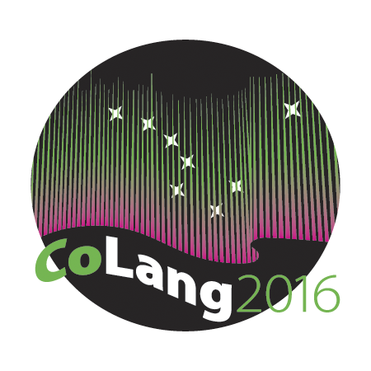
Colang 2016 Workshop Syllabus

Workshop Title: Grant-writing
Instructors' names and emails: Spike Gildea <spike@uoregon.edu> and Margaret Florey <mflorey@rnld.org>
Course materials: handouts and PDFs of PowerPoints will be made available throughout the course
Supplies needed: Laptop, ideas for a project for which you would like to seek funding

Course goals: This course provides an overview of the key national and international funding agencies. The essential information that is commonly required by funding agencies is reviewed and explored section-by- section. Students will practise writing sections of a mock proposal and will receive feedback about what works and what doesn’t in grant applications. Ethical and intellectual property issues are discussed and we examine the requirements for carrying out effective projects consistent with community protocols.

Student learning objectives: Students will learn to prioritise project goals and identify a component of their project for which they might seek funding. They will be able to identify key sections of a Request for Proposals and apply their project goals to the RFP. Drafting of sections of a mock proposal will strengthen their ability to prepare a succinct summary of the project. They will gain an understanding of a realistic project timeline and will learn to identify and prioritise key budget items.

Instructional methods: This course will include lecture sessions, group discussions and hands-on exercises in writing sections of grant applications.

Evaluation: Evaluation will be based on a draft of several sections of a grant application, including: identification of a potential project and appropriate funding agency, 100 word project summary, project timeline and budget items. These sections will be assessed against the guidelines the students practice using in class.

Disabilities services: The Office of Disability Services implements the Americans with Disabilities Act (ADA), and insures that UAF students have equal access to the campus and course materials. The instructor will work with the Office of Disabilities Services (208 WHIT, 474-5655) to provide reasonable accommodation to students with disabilities.

