
TOTAL PROJECT COST INCREASE

Name of Project: Campus Wide Food Court Renovations

Location of Project: Fairbanks Campus: Wood Center

Project Number: 2007199 CWFS

Date of Request: November 7, 2007

Project Manager: Marc Wohlford, PE

Estimated Total Project Cost: $1,000,000
$1,750,000
Approval Required: FLM Committee

INTRODUCTION
In accordance with Regents’ Policy P05.12, Schematic Design Approval (SDA) represents approval of the location of the facility, its relationship to other facilities, the functional relationship of interior areas, the basic design including construction materials, mechanical, electrical, technology infrastructure, and telecommunications systems, and any other changes to the project since Formal Project Approval.

Unless otherwise designated by the approval authority or a Material Change in the project is subsequently identified, SDA also represents approval of the proposed cost of the next phase(s) of the project and authorization to complete the Construction Documents process, to bid and award a contract within the approved budget, and to proceed to completion of project construction. Provided, however, if a Material Change in the project is subsequently identified, such change will be subject to the approval process described below.

For the Schematic Design Approval, if there has been no Material Change in the project since the Formal Project Approval, approval levels shall be as follows:

- TPC > $4 million will require approval by the Facilities and Land Management Committee (F&LMC).
- TPC > $2 million but ≤ $4 million will require approval by the chair of the F&LMC.
- TPC ≤ $2 million will require approval by the university’s Chief Finance Officer (CFO) or designee.

If there has been a Material Change in the project since the Formal Project Approval, the Schematic Design approval levels shall be the same as the Formal Project Approval.

BODY OF THE APPROVAL

1. Narrative Description
The UAF Dining Services department provides meal plans and options to nearly 5000 students, staff, and faculty each day. During Fiscal Year 2007, UAF, UAA, and UAS advertised for and selected a new food service contractor for all three MAU’s. This integrated food services contract follows the guidelines and practices established by UA to reduce cost and increase accountability through the ACAS program. The bid was delayed for several months while statewide and the three MAU’s revised the RFP’s to ensure all three MAU’s would get the lowest cost structure possible.

The new contract was effective on July 1, 2007 and was awarded to NANA Management Services. The agreement includes commitments that UAF will make modifications to various food service spaces (Wood Center, Upper Dorm Hess Commons, Arctic Health Café and Lola Tilly Commons) to allow the implementation of a new meal plan on UAF campus.

Modifications to the Wood Center were rated as the highest priority, this involved modifying the 1970’s cafeteria-line venue to a current multiple vendor venue. The work schedule was always tight, completing $1,000,000 worth of work between June 2007 and August 2007. The delay of the RFP, then made it unreasonable that the project would be able to be completed by the end of August. Extending the construction duration into September was deemed more desirable that delaying the entire renovation until May 2008.

A single source approval to select a construction contractor was requested from the Chief Procurement Officer per AS36.30.300 and Regents Policy P05.06.415. Approval allowed the Wood Center Food Court renovations to begin much quicker. Alcan Builders, Incorporated was awarded a Time and Materials contract with a maximum not to exceed amount.

Formal Project and Schematic Design approval were given by the Chief Finance Officer’s designee (R. Schointuch) on June 18th in the amount of $1.0million total project cost.

The design for Wood Center was initiated by NANA in order to adequately address their needs for new space in the building. UAF used the preliminary design criteria and contracted with the consulting firm of Porath Tatom in Anchorage to fast track the renovation design and provide final construction drawings. The final documents were received on August 10th. Once the design was complete, Alcan Builders began work in earnest while simultaneously providing UAF with an estimated construction cost for the remainder of the project. There was a high level of heavy duty commercial construction and the food service area in the Wood Center was essentially gutted back to bare walls to make way for new construction.

- Graphic Description

See Attached

- Proposed Cost and Funding Source(s)

Additional funds will be provided by the UAF Dining Services Auxiliary Funds and UAF Maintenance Funds.

- Estimated Total Project Cost
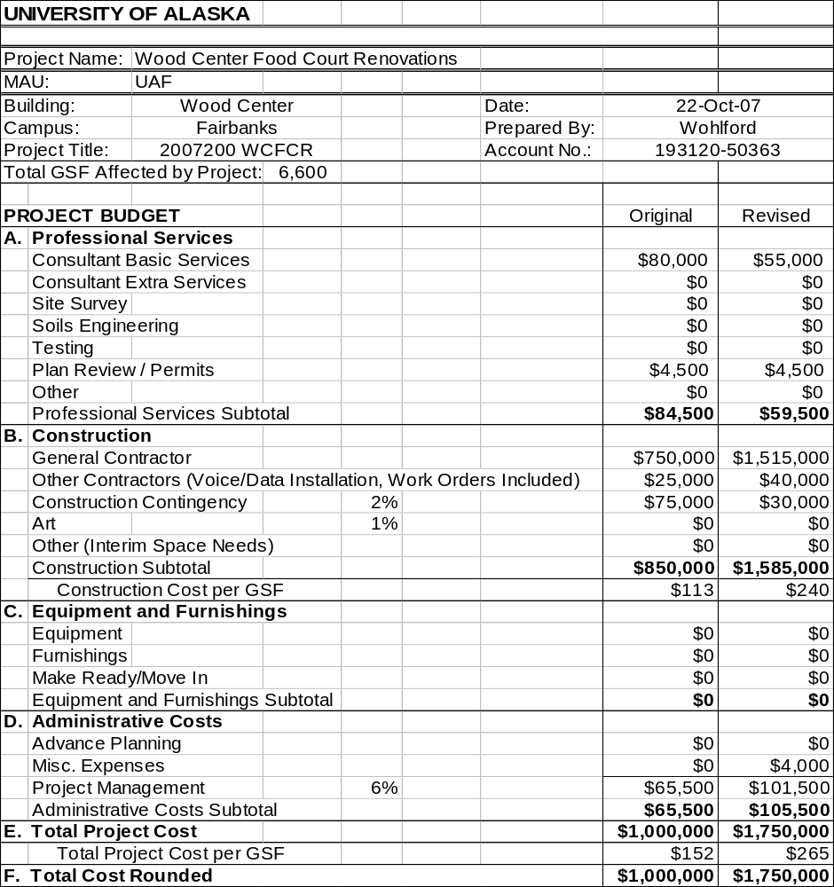

5. Variance Report

Identify any significant changes in scope, cost, schedule, funding plan, operating cost impact, or other cost considerations from the time the project received Formal Project Approval.

The overall project scope has been changed from four minor renovations to one large renovation project. For the Wood Center itself, the scope remains the same, but the timeline decreased and the quality and type of materials increased. The newer, more stringent building codes required a rated shaft enclosure around the new exhaust fans that was not anticipated. Material selections were altered to provide longer lasting materials that also enhanced the appeal of the dining area in hopes of attracting more customers. The new lighting also changed to more efficient fixtures which allow varying levels of light. At least 30% of the total project cost went towards items in the Wood Center Deferred Renewal List. The project costs have increased due to these modifications. The original budget did not anticipate the high level finishes, code issues, energy savings, or deferred renewal. The budget also did not account for the complete demolition of the areas infrastructure, which was required to accommodate the much larger kitchen layout. Overall though, the cost per square foot of $265/SF is much less than other current renovation projects on the Fairbanks and Anchorage campuses.

- Schedule for Completion
Original Schedule:
Schematic Design Complete June 22, 2007
Design Complete: July 6, 2007
Construction Complete August 30, 2007

Final Schedule:
Design Complete: August 10, 2007
Construction Complete: October 5, 2007

7. Affirmation

Prior approvals are listed in the Board of Regents meeting minutes on the following dates:

Formal Project and Schematic Design Approval by Chief Finance Officer’s designee on June 11, 2007.

8. Action Requested

Total Project Cost Increase for the Campus Wide Food Service Renovations from $1,000,000 original amount to $1,750,000 an increase of $750,000

9. Approval
The President recommends that:

MOTION

“As required by Regents’ Policy P05.12.04, the Facilities and Land Management Committee of the Board of Regents approves the Total Project Cost Increase request for the University of Alaska Fairbanks Campus Wide Food Service Renovations as presented, with a revised Total Project Cost not to exceed $1,750,000. This motion is effective December 5, 2007.”

Supporting Documents:

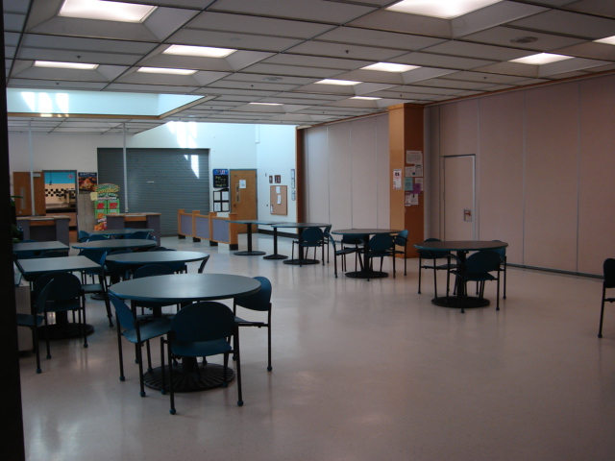
Before Photo showing the dining area with the old kitchen in the distance.

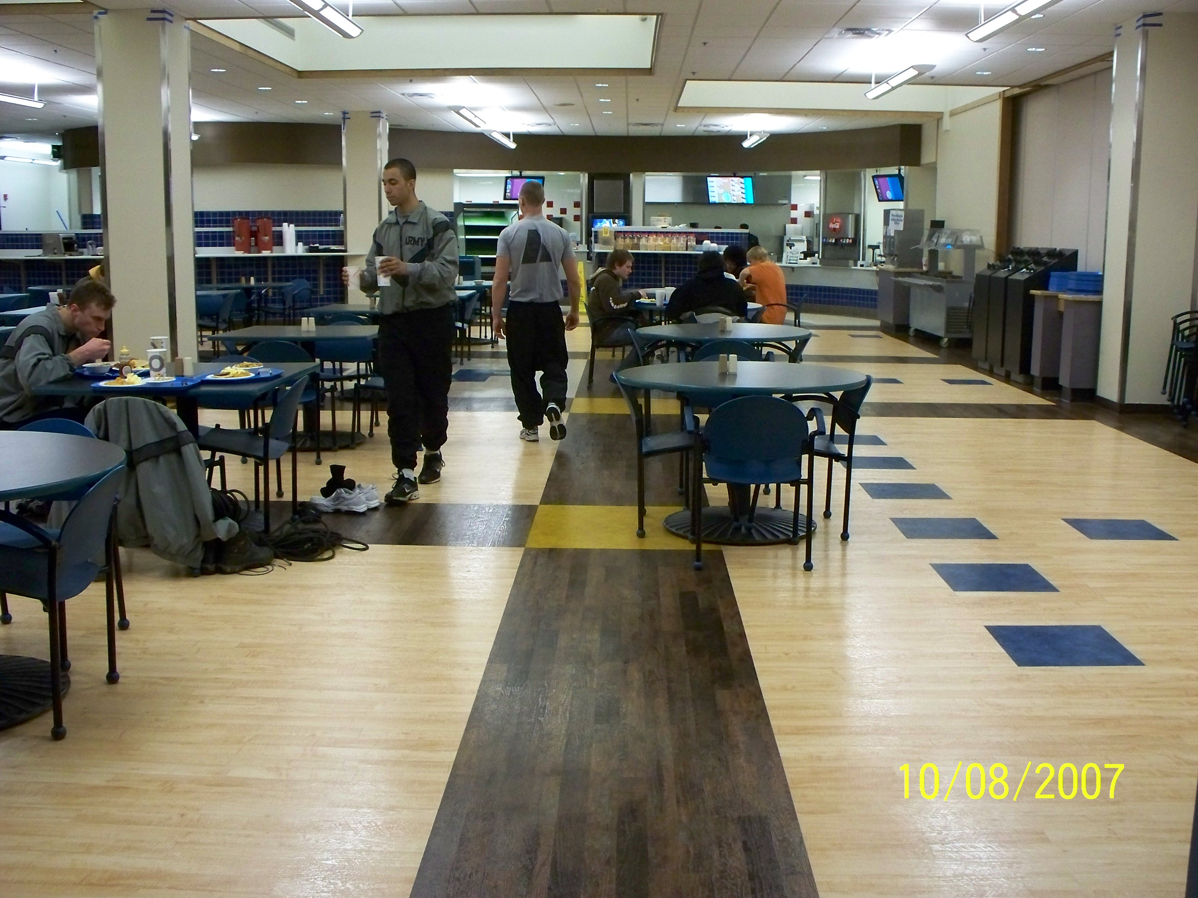
After Photo showing the new dining area and new kitchen in the distance.

