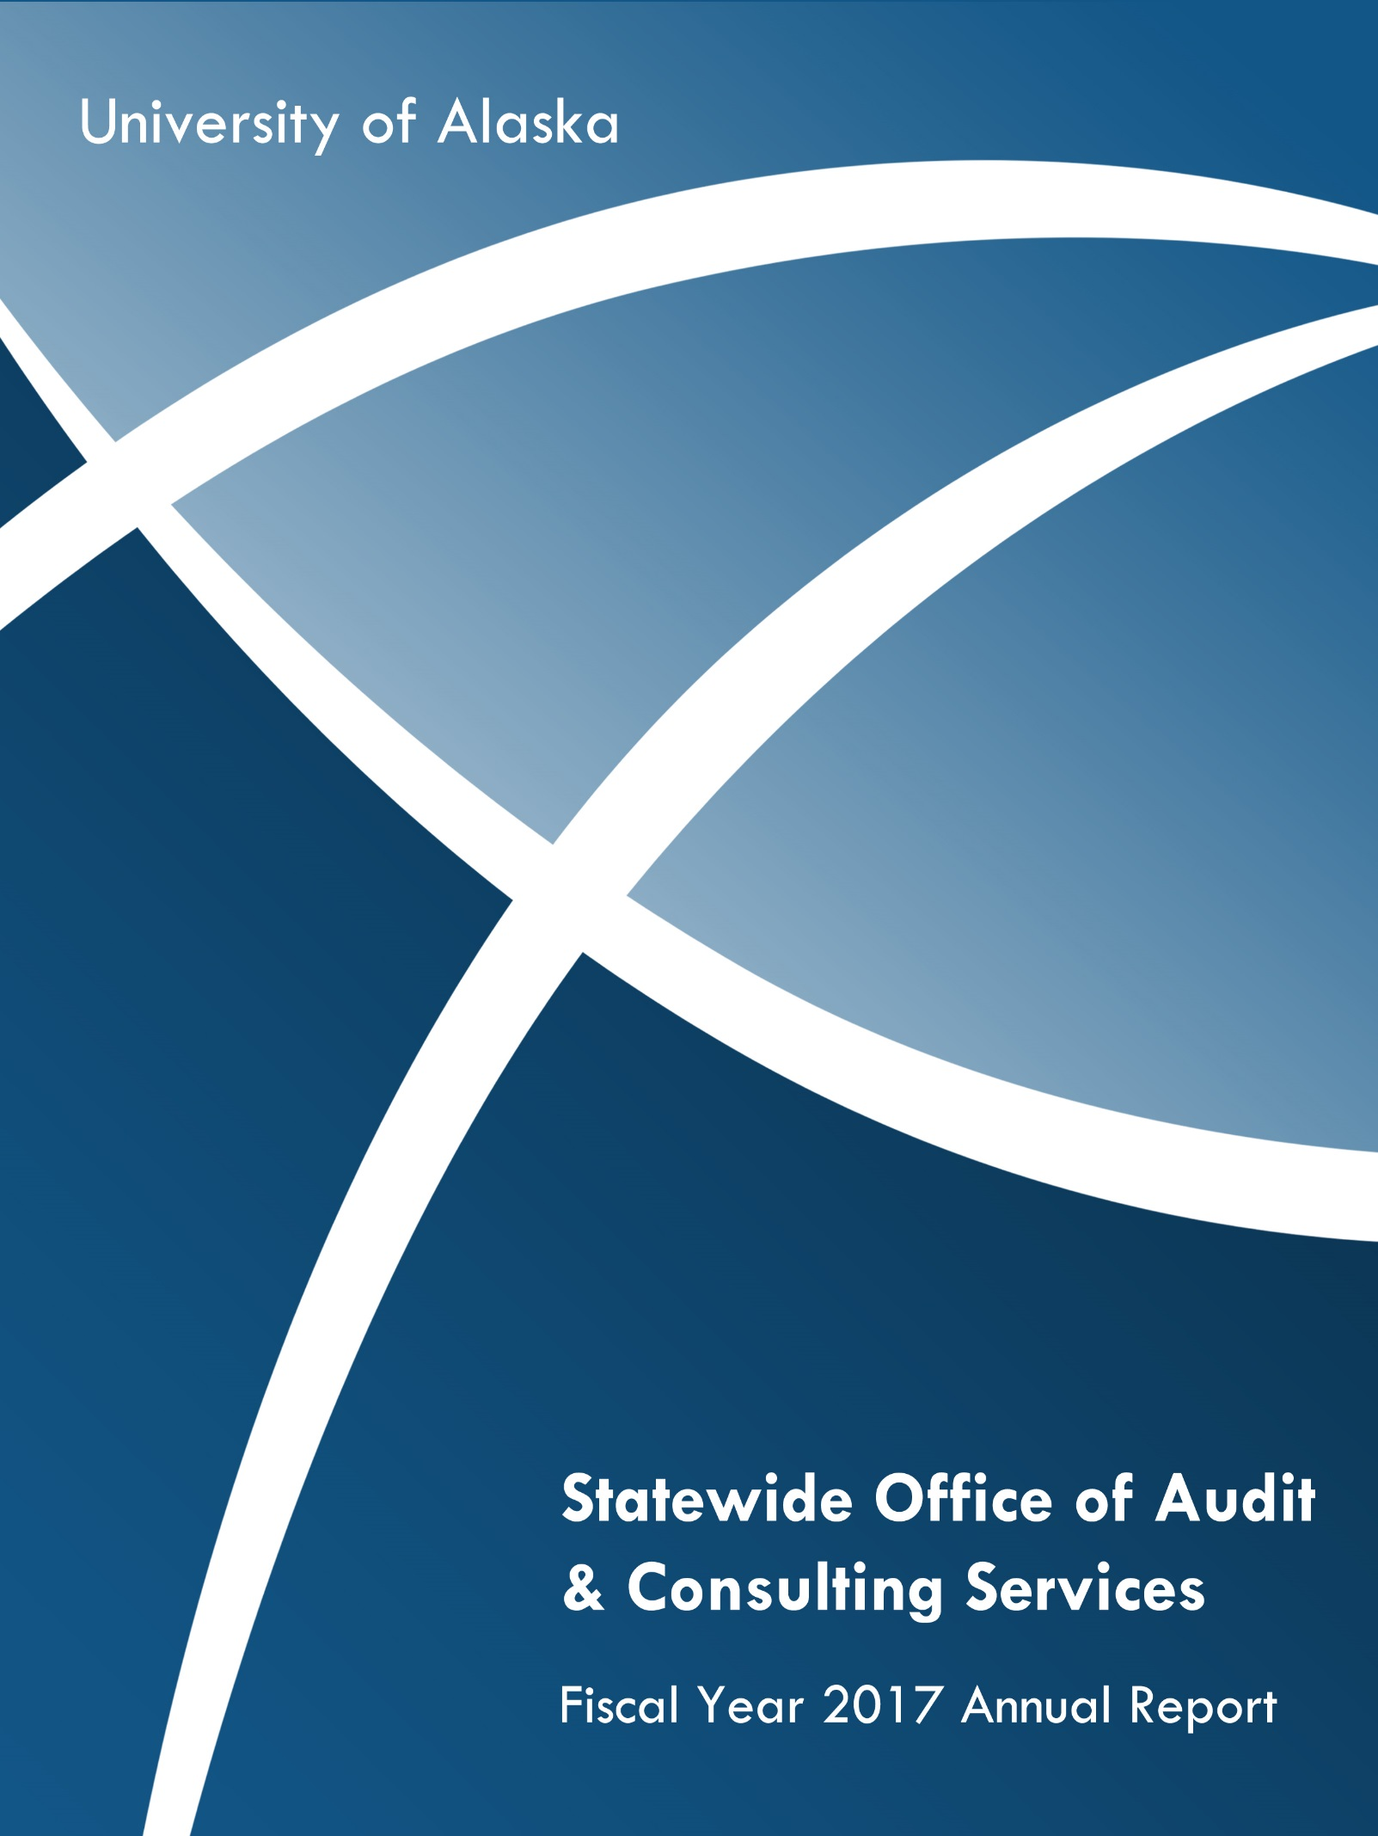

Table of Contents

Executive Summary 1
Confirmation of Organizational Independence 2
Organizational Chart 3
Audit Staff Profile 4
Audits and Projects Completed in FY17 5
Final Status of the FY17 Audit Plan 7
2017 Fiscal Year Goals and Accomplishments 9
Audit Engagement Goals 9
Staffing Goals 10
Quality Assurance (QA) Goals 11
Outreach Goals 11
Status of FY2018 Annual Audit Plan 12
External Financial Audit Support 12
Audits and Projects 12
Compliance Reviews 12
Function and System Reviews** 12
Information Systems Reviews** 12
Ongoing Audits 12
External Audit Status Report 13
External Audit Reports & Activities 13

Strategic Partners for Shaping Alaska’s Future

Executive Summary
The Board of Regents of the University of Alaska has oversight responsibility of internal and external audit functions, and for ascertaining the existence and adequacy of accounting and internal control systems and safeguards over University assets. The mission of the Office of Audit and Consulting Services (A&CS) is to “Assist the board and management in the effective discharge of their fiduciary and administrative responsibilities by providing analysis, appraisals, counsel, information and recommendations concerning activities reviewed and by promoting effective controls for the recording and reporting of operational activities and for the custody and safeguarding of assets.”
This report contains an overview of the A&CS organization, a summarization of the internal reports issued over the past fiscal year and progress made toward completing the FY2017 and FY2018 audit plans. The information provided in this report documents how A&CS assists management in mitigating risk and identifying improvements to UA operations. Management responded to the audit report recommendations from the past year with adequate action plans or acceptance of the risk by not taking action. Action plans and acceptance of risk were communicated via final audit reports.
This report is being provided in accordance with the audit charter, which states:
- P05.03.020. Organization.
- The chief audit executive shall report administratively to the chief finance officer and functionally to the chair of the Audit Committee of the board.
- P05.03.026. Audit Planning.
- The chief audit executive shall independently develop the annual audit plan using a risk-based prioritization of the audit universe.
- The chief audit executive shall present the audit plan to the Audit Committee for review and approval.
- Significant deviation from the formally approved plan will be communicated to senior management and the Audit Committee through periodic status reports.
The A&CS charter was developed in accordance with the internal auditing standards promulgated by the International Institute of Internal Auditors (IIA):
Standard 2010 “The chief audit executive must establish risk-based plans to determine the priorities of the internal audit activity, consistent with the organization’s goals. The internal audit activity’s plan of engagements must be based on a documented risk assessment, undertaken at least annually. The input of senior management and the board must be considered in this process.”
Standard 2020 “The chief audit executive must communicate the internal audit activity’s plans and resource requirements, including significant interim changes, to senior management and the board for review and approval.”
Standard 2060 “The chief audit executive must report periodically to senior management and the board on the internal audit activity’s purpose, authority, responsibility, and performance relative to its plan…”

Confirmation of Organizational Independence
The Office of Audit and Consulting Services (A&CS) confirms its organizational independence to the Board of Regents Audit Committee.
- The chief audit executive (CAE) had direct and unrestricted access to senior management.
- The CAE and staff performed their work objectively – no quality compromises were made and judgment on audit matters was not subordinated to any others in the organization.
- The CAE and staff had no conflict of interest situations and did not perform operational duties or make management decisions external to A&CS.
- A&CS had no impairments to organizational independence such as scope limitations; restrictions on access to records, personnel, properties; or resource limitations.
Institute of Internal Auditors Standards for Independence:
- 1100 – Independence and Objectivity
The internal audit activity must be independent, and internal auditors must be objective in performing their work.
- 1110 – Organizational Independence
The chief audit executive must report to a level within the organization that allows the internal audit activity to fulfill its responsibilities. The chief audit executive must confirm to the board, at least annually, the organizational independence of the internal audit activity.
- 1111 – Direct Interaction with the Board
The chief audit executive must communicate and interact directly with the board.
- 1120 – Individual Objectivity
Internal auditors must have an impartial, unbiased attitude and avoid any conflict of interest.
- 1130 – Impairment to Independence or Objectivity
If independence or objectivity is impaired in fact or appearance, the details of the impairment must be disclosed to the appropriate parties. The nature of the disclosure will depend upon the impairment.

Organizational Chart
As of August 2017
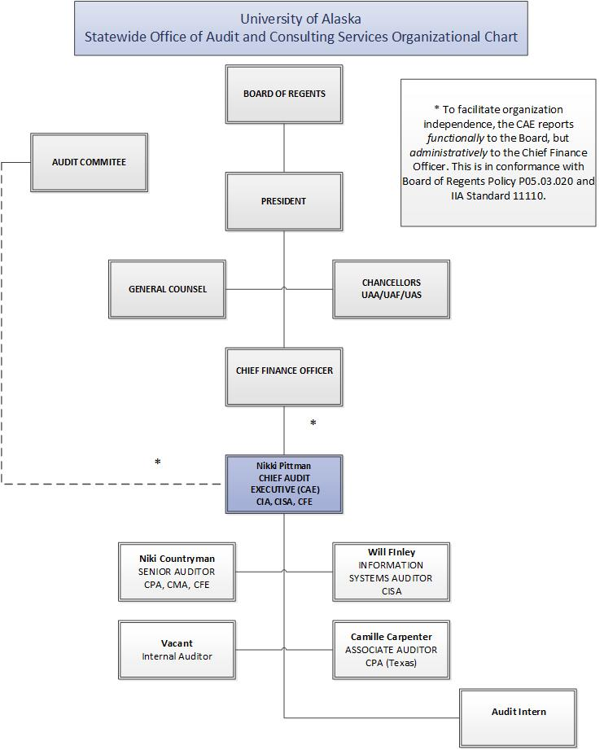

Audit Staff Profile
Five professional audit staff serve all locations within the UA system. We are currently recruiting to fill one vacancy within the five positions. A School of Management student is often hired as an audit intern to assist with projects such as follow-up auditing and development of flowcharts.
The internal auditors have a variety of specialized subject matter expertise:
- 2 Certified Information Systems Auditors (CISA)
- 2 Masters of Business Administration (MBA)
- 2 Certified Public Accountants (CPA)
- 1 Certified Internal Auditor (CIA)
- 1 Certified Management Accountant (CMA)
- 2 Certified Fraud Examiners (CFE)
Auditors continue to pursue professional certifications such as the CIA.
Achievement of professional certifications supports A&CS in the overall achievement of its FY18 Annual Audit Plan, which is consistent with the IIA Standards, the Code of Ethics, and the direction of the internal audit profession to serve as independent yet trusted advisors to their organizations.

Audits and Projects Completed in FY17
During the period from July 2016 to June 2017 the following engagements were completed:
Institution | Engagement Title | Procedures Performed | Outcome
UA System | Sponsored Programs Effort Certification | A selection of 50 labor transactions were examined to test the completeness, accuracy and timeliness of job forms, appointment letters and effort certifications. 20 of the 50 were labor transactions that correlated with the surveys that were conducted for a selection of PIs. Effort reporting for these transactions were tested for reasonableness, allowability and allocability.  A selection of 10 labor redistributions and 5 matching funds labor transactions were examined to test for accuracy, timeliness, and reasonableness.  Two surveys were conducted:  • A survey of 20 questionnaires was sent to principle investigators (PIs) to test internal controls in grant management, knowledge of regulations, training provided and monitoring methods for awards.  • A survey of 15 questionnaires was sent to department fiscal managers to test the adequacy of internal controls that effort reported was complete, training provided was adequate and monitoring of the grant activity was adequate. | Report Status: Final audit report pending one response.
UA System | Cyber-resiliency IT Risk Management | Interviews were conducted with executive and mid-level managers associated with scoped systems:  - Enterprise information systems (core systems)  - Banner  - OnBase  - BlackBoard Transact  Information was also gathered from a review of documents including the annual IT risk survey, the IT change management process, and the incident management process description, requested from OIT staff. | Report Status: Final audit report in development.
UA System | Departmental Risk Management | Six areas were selected based on student involvement in activities or departments with inherent risks to students:  1) UAA ANSEP, 2) UAA Health, Physical Education and Recreation, 3) UAF Art Department, 4) UAF MAPTS, 5) UAS Student Activities, 6) UAS Career Education.  The review included audio conferences and in-person interviews with risk managers and directors. Walk-throughs were conducted during on-site visits to the UAF Art Department and the UAF MAPTS – Delta Junction training mine.  Documents reviewed included policy and procedure manuals, websites, organizational charts, insurance waivers, safety inspections, acknowledgment of risk forms, departmental emergency action plans, meeting minutes, agreement for minor’s participation in activities, third party reports, evaluations, response protocols, loss prevention applications, safety equipment quotes and prior external audit reports. | Report Status: Preliminary audit report in development.
UAA  and UAF | Contract Compliance | Interviews were conducted with the chief procurement officer, leadership and staff members related to the following contracts:  - UAF  - Chartwells Dining Services contract  - Follett Higher Education Group contract  - UAA  - NMS, LLC AAC addendum  - Global Spectrum, L.P.  Contract documents, modifications and addendum were reviewed, as well as purchase orders and certificates of insurance. A randomly chosen sample of invoices was reviewed for the UAF Chartwells Dining Services and the UAA Global Spectrum contracts. Data and documentation supporting the commission statements which Follett provided to UAF was reviewed. | Report Status: Preliminary audit report in development.
UAA | College of Education Human Resources and Payroll | The HR and payroll documentation for the academic terms Summer 2015 through Fall 2016 was reviewed for a selection of fourteen faculty and adjunct instructors.  Internal control questionnaires were performed with the assistant to the dean, fiscal manager, and fiscal professional to gain an understanding of the processes and key controls. Processes and controls were also reviewed with the Office of Academic Affairs (OAA) to assure that a thorough understanding of University expectations and bargaining unit requirements was obtained. Process flow charts were developed and discussed with the College. | Report Status: Preliminary audit report awaiting formal response.
SW | Pension Plan Fiduciary Oversight | Reviewed with SW HR personnel the process for performing the fiduciary oversight responsibilities for the pension plan. Discussed tentative recommendations with the Office of General Counsel and HR. | Report Status: Memo for the CHRO is being developed.

Final Status of the FY17 Audit Plan
The following outlines the status of planned activities for fiscal year 2017. These activities were presented and approved by the Board of Regents Audit Committee in June 2016.
Status of FY17 Activities
Scheduled Projects Completed | - FYE16 External Audit  - Payroll  - Journal Entries  - Disbursements  - Wires  - Tuition and Fees  - Procurement Card  - Search for Unrecorded Liabilities  - Plant, Property and Equipment  - State of Alaska Executive Travel and Compensation Report for CY2016  - Cyber-resiliency IT Risk Management  - Pension Plan Fiduciary Oversight  - Departmental Risk Management  - Contract Compliance
Added Projects Completed | - Investigations  - UAA College of Education Human Resources and Payroll
Projects Completed from Prior Years | - System-wide Sponsored Programs Effort Certification
Project Incorporated into FY17 | - External Audit of HIPAA Compliance
Projects Deferred | - Clery Act (FY18)  - Protection of Minors (FY19)  - Enrollment (Strategic Pathways)  - Disability Support Services  - Fleet Management  - IT Controls Management (replaced by external HIPAA audit)  - IT Governance: Data and Reporting (Strategic Pathways)
Other Activities | - Follow-up Auditing  - Continuous Controls Auditing  - Tracked 19 external audits with some still in progress  - UA Confidential Hotline - System-wide administration  - Participated in:  - Payment Card Industry (PCI) Work Group  - Computer Incident Response Team (CIRT)  - Travel System Replacement  - Strategic Pathways - Finance  - Advisory:  - Disbursements Segregation of Duties  - Wires Process Segregation of Duties and Flowchart  - Google Docs HIPAA Compliance  - Bank Reconciliation Process and Controls Overview  - Gramm-Leach-Bliley Act Compliance
In Progress | - Attorney-Client Privileged Audits (2)  - Business Continuity/Disaster Recovery  - Fraud Risk Assessment for Procurement and Accounts Payable  - Management Reporting

2017 Fiscal Year Goals and Accomplishments
Audit and Consulting Services Mission Statement
The mission of the audit and consulting services department is to assist the board and management in the effective discharge of their fiduciary and administrative responsibilities by providing analysis, appraisals, counsel, information and recommendations concerning activities reviewed and by promoting effective controls for the recording and reporting of operational activities and for the custody and safeguarding of assets.
The International Institute of Internal Auditors (IIA) defines internal auditing as “…an independent, objective assurance and consulting activity designed to add value and improve an organization’s operations. It helps an organization accomplish its objectives by bringing a systematic, disciplined approach to evaluate and improve the effectiveness of risk management, control and governance processes.”
To meet the department’s mission and the definition of internal auditing, the Office of Audit and Consulting Services establishes annual goals in four strategic areas: Audit Engagements, Staffing, Quality Assurance and Outreach.
Accomplishments achieved in fiscal year 2017 are outlined as follows:
Audit Engagement Goals | Accomplishments
- Effectively identify the best use of limited audit resources to maximize broad-based coverage in key risk areas. | Used a risk-based process to identify engagements for the audit plan. The process included interviews with senior leadership, discussion with the Board of Regents and external auditors, industry analysis, and results from prior audits: internal, external and agency. The resulting audit plan was presented to the President, executive management, and the Audit Committee for their approval.  A&CS completed 6 engagements and issued 3 reports, with 3 more reports in the reporting stage.
- Maximize benefit of all external audit services. | Acted as a liaison with external auditors in relation to legislative, federal compliance and financial statement audits.
- Make value-added recommendations that identify strengths and system improvements to better meet objectives. | Completed follow-up audit procedures on 30 open recommendations from prior audits, noting that 20 were implemented and the remaining 10 were in-progress. FY17 ended with 68 recommendations with follow-up in progress or to be performed in the future. This figure excludes the recommendations from the 2011 Coalfire Systems information security review. Rather than follow-up on each recommendation, we incorporated in-depth audits of the highest ranked risks into annual audit plans.
- Identify and effectively respond to risks associated with fraud, waste and abuse. | A fraud risk assessment is being performed for the procurement and related accounts payable function.  1 investigation completed; 2 are in progress. Follow-up on 1 prior investigation also occurred.  6 instances where the potential for fraud, waste or abuse were reviewed and deemed that an investigation was not necessary, or the determination is in-progress.  Toll Free 855-251-5719  The chief audit executive and the senior auditor are Certified Fraud Examiners.  Each auditor attended fraud training.  Audit-level risk assessments include a fraud risk assessment.
Staffing Goals | Accomplishments
Employ highly-effective personnel that possess the technical and effective communication skill sets necessary to ensure successful identification and implementation of value-added recommendations. | Two auditors are preparing for the Certified Internal Auditor exam.  Annual career development planning was conducted with all audit staff.  Performance evaluations were conducted for all audit staff.  Each auditor received a minimum of 40 continuing professional education units (CPEs) to improve their knowledge on higher education audit topics and techniques, remain abreast of emerging higher education risks, and achieve and maintain a high level of performance. A minimum of 40 CPE are required by governmental auditing standards. Additionally, certified auditors complied with the CPE requirements of their certifying organizations.  All staff participated in professional organizations to remain current on industry and technical trends as well as to facilitate networking opportunities. Staff member participation included:  - Systems of Higher Education Chief Audit Executive forum.  - Association of College and University Auditors Professional Education Committee Chair.  - Co-presenting at a Treasury Institute for Higher Education Workshop
Quality Assurance (QA) Goals | Accomplishments
Employ internal operational practices that comply with auditing standards and promote efficient use of limited resources. | - 2017 - The CAE participated on QAR teams for Oregon State University and Idaho State University in FY17.  - 2017 - Implementation of 2016 QAR recommendations.  - 2016 - Received a rating of “Generally Conforms” from a peer review conducted by the chief audit executive from Washington State University. This is the highest possible rating and signifies an upgrade from the prior rating in 2011 of “Partially Conforms.” It highlights the improvements the department continues to make on an ongoing basis. The review is required to occur at a minimum of every 5 years.
Outreach Goals | Accomplishments
Provide valuable resources through system-wide communication and education to assist campuses in meeting their objectives. | Provided:  - Presentation on internal audit and internal controls to UAF grants and contracts personnel.  - Statistics on the reports received through the UA Confidential Hotline and directly to A&CS.  - Information about fraud and emerging risks occurring at other higher education institutions.  - Resources on risk assessment processes and enterprise risk management theory.  - Up-to-date information on the department website:  www.alaska.edu/audit  Regularly attended board and executive leadership team meetings to remain current on institutional changes and provide consultation on current issues and initiatives.  Discussed compliance and information security within ad-hoc and formal committees.

Status of FY2018 Annual Audit Plan
As of August 2017
Italic Items - Have been completed or are in progress

External Financial Audit Support

Payroll
Journal Entries
Cash Disbursements
Tuition and Fees
Wires
Procurement Card
Search for Unrecorded Liabilities
Property

Audits and Projects

Compliance Reviews*
- Clery Act
- Gramm, Leach Bliley Act
- Subrecipient Monitoring
Function and System Reviews**
- Loss Prevention
- Revenues and Banking
- Tuition and Fees
- Ethics/Conflict of Interest
- Business Offices
Information Systems Reviews**
- Data Centers
- Network
- Oracle Database
Ongoing Audits
- Follow-up Auditing
- Continuous Controls Auditing

Legend:
* Specific topics are subject to change as planning discussions are held with each university. Process reviews will aim to result in the following documentation, as applicable: Flow chart of the current process, flow chart of the process with future changes (if future changes are indicated by the key departments), and RACI chart. In some instances, an audit report with recommendations may be warranted.
** Specific departments/areas to be determined during planning for specified audit or project. These will be selected from any of the universities or system offices.

External Audit Status Report

External Audit Reports & Activities

Completed:
- FY10-FY11 Fringe Benefit Incurred Costs (DCAA) – report pending
- FY17 Fringe Benefit Rate Forward Pricing (DCAA) – report pending

Work in Progress:
- UA Annual Financial Audit FY17 (Moss Adams)
- UA Federal Single Audit FY17 (Moss Adams)
- UA Foundation and Consolidated Fund FY17 (Moss Adams)
- Rasmuson Foundation Donor Intent (Moss Adams)
- Education Trust of Alaska (PWC)
- GASB 68 (KPMG)
- FY12-FY14 Fringe Benefit Incurred Costs (DCAA)
- FY18 Fringe Benefit Rate Forward Pricing
- UAF Federal Property (ONR)
- UAF OIG Audit of Sikuliaq NSF Awards (NSF OIG)

Throughout the year, new risks and competing priorities arise, resulting in the need to revise the original audit plan. Some of the FY17 topics were reviewed extensively through the Strategic Pathways review and would have been duplicative to have an audit performed this year.

