Alaska Seafood Processing Leadership Institute (ASPLI)
Fall Update, November 2015

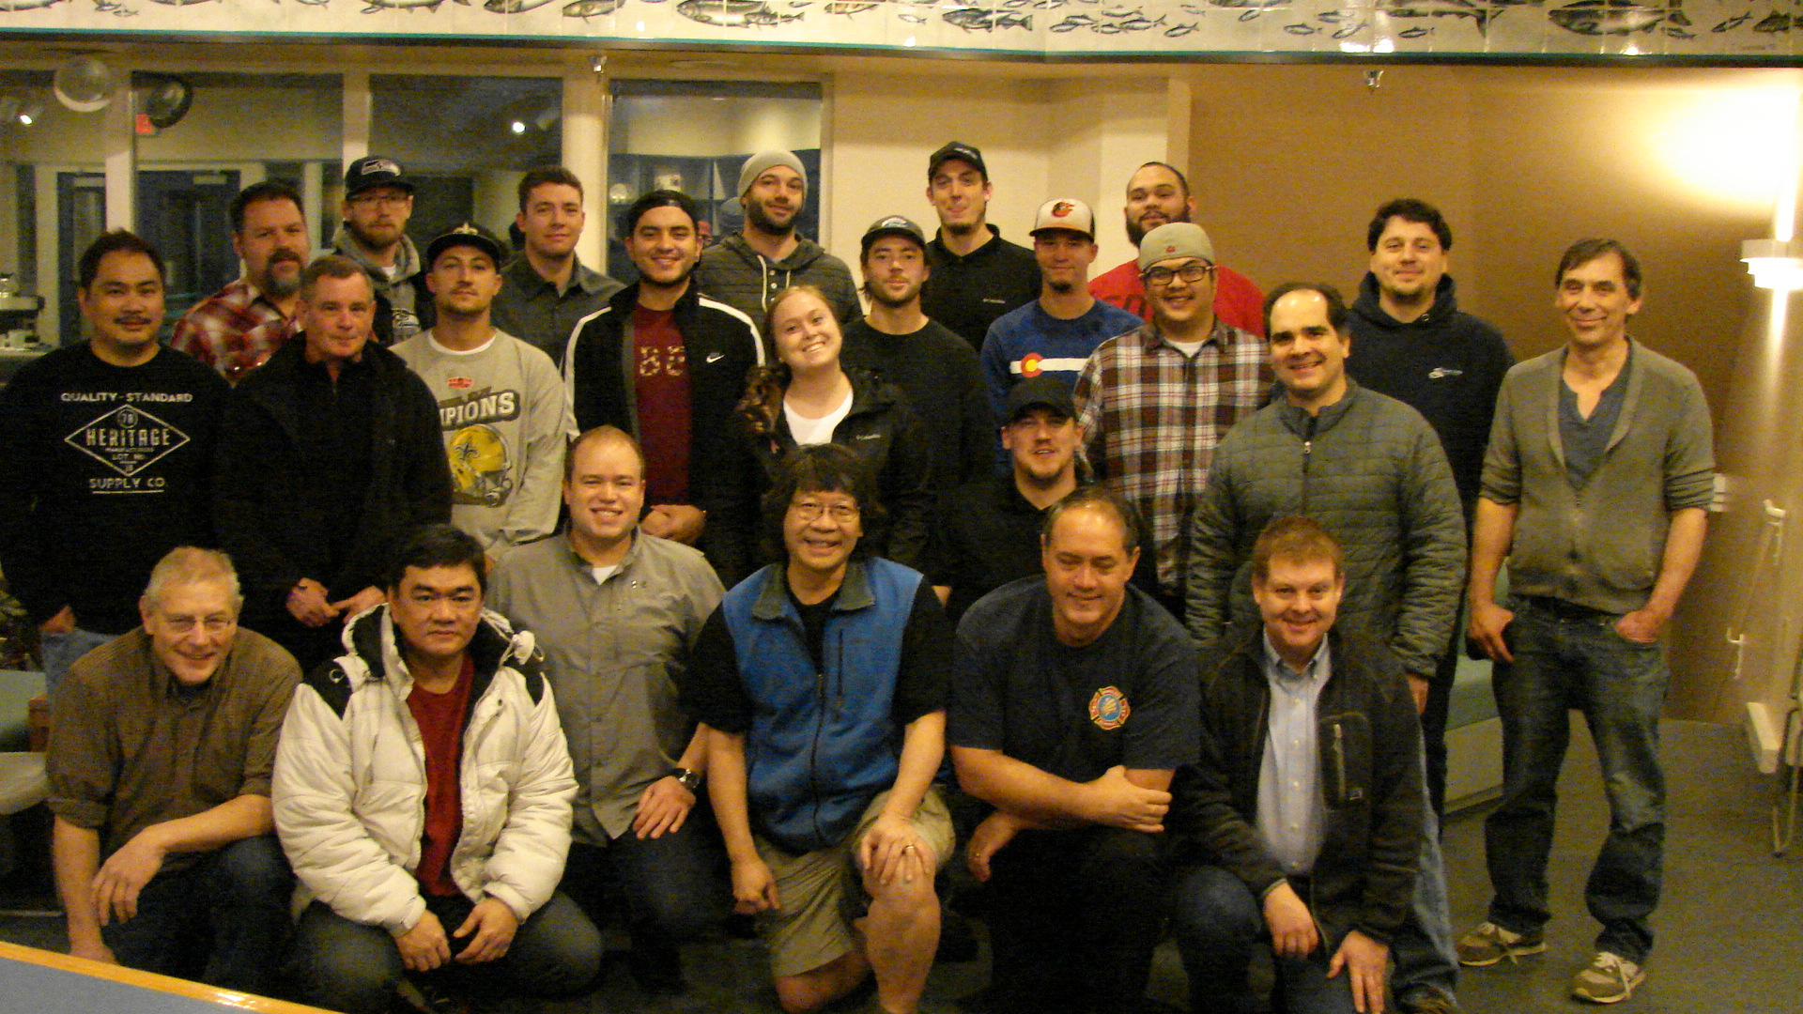
The Alaska Seafood Processing Leadership Institute (ASPLI) session 1 was held last week at the Kodiak Seafood and Marine Science Center. Twenty two participants are attending the institute, from Alaska General Seafoods, APICDA, Coastal Cold Storage, Icicle Seafoods, Norton Sound Seafood Products, Peter Pan Seafoods, Silver Bay Seafoods, Trident Seafoods, Unisea, two direct marketers supported by the Bristol Bay Economic Development Corporation and a CES faculty member. They traveled from Ketchikan, Kodiak, Dutch Harbor, Naknek, Pilot Point, Larsen Bay, Homer, Nome, Unalakleet, Dillingham, Fairbanks, Anchorage and Seattle for the institute. The group includes individuals with titles of production manager, assistant plant manager, HR director, QC manager, field office coordinator, assistant fleet manager, production supervisor, first machinist, retort operator and plant owner.

The first intensive 5-day session included information on the business of seafood processing; seafood safety and quality as part of corporate identity; upcoming changes in requirements for seafood processors; innovations in seafood packaging and mechanization and the DEC regulatory process. Lean manufacturing was the subject of a daylong session and another day was devoted to project management training. The group heard from long time plant manager Jim Majors and toured the Trident plant and Pickled Willys smoking operation in Kodiak. A local seafood chef prepared lunch each day and the group processed salmon jerky in the seafood processing pilot plant as a team building activity.

Over the winter, each participant will work with a mentor to complete a project of value to his or her company. In early March, the group comes back together in Anchorage for another 5 days of training with a focus on leadership, human resources, marketing and understanding and participating in the seafood regulatory process. Following the Anchorage class, a number of ASPLI participants will travel together to the International Seafood Expo in Boston.
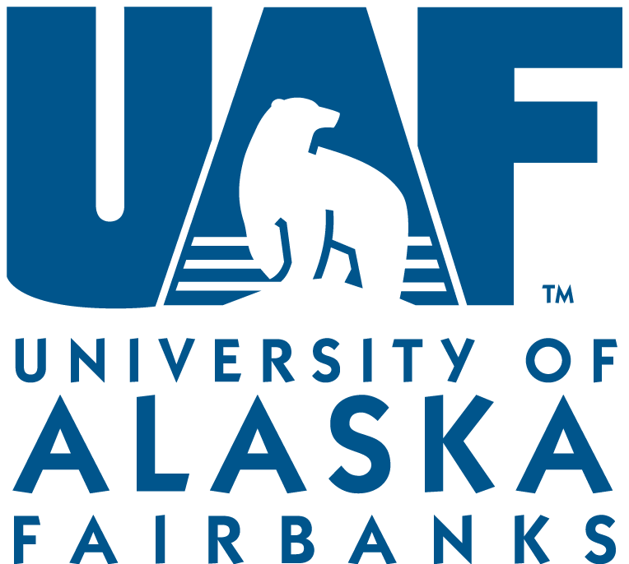
ASPLI is an intensive professional development program offered by the Alaska Sea Grant Program targeting rising leaders in Alaska’s seafood industry. Funding for ASPLI is from participant fees, University of Alaska TVEP funds and Alaska Sea Grant. Coordinators are Marine Advisory faculty members -Dr. Quentin Fong (qsfong@alaska.edu), Chris Sannito and Paula Cullenberg.

