ITSM Process Description
Office of Information Technology
Incident Management

Contents
Introduction
Incident Management Purpose and Objective
Incident Management Scope
Benefits
Benefits to the IT Service Providers
Benefits to the Customers
Key Terms and Definitions
Roles and Responsibilities
Incident Management Process Owner
Incident Management Process Manager
Incident Management Analyst
Service Desk
N-Level Support Group
User

1. Introduction
The purpose of this document is to provide a general overview of the Office of Information Technology (OIT) Incident Management Process. It includes Incident Management goals, objectives, scope, benefits, key terms, roles, responsibilities, authority, process diagrams and associated activity descriptions.

The content within this general overview is based on the best practices of the ITIL® framework[1].

2. Incident Management Goals, Objectives, CSFs and KPIs
Goals, objectives and critical success factors (CSFs) define why Incident Management is important to the Office of Information Technology’s overall vision for delivering and supporting effective and efficient IT services. This section establishes the fundamental goals, objectives and CSFs that underpin the Incident Management process. The agreed and documented goals, objectives and CSFs provide a point of reference to check implementation and operational decisions and activities.

Incident Management is the process responsible for managing the lifecycle of all Incidents irrespective of their origination.

The goals for the Incident Management process are to:
· Restore normal service operation as quickly as possible
· Minimize the adverse impact on business operations
· Ensure that agreed levels of service quality are maintained

To achieve this, the objectives of OIT’s Incident Management process are to:

· Ensure that standardized methods and procedures are used for efficient and prompt response, analysis, documentation, ongoing management and reporting of Incidents
· Increase visibility and communication of Incidents to business and IT support staff
· Enhance business perception of IT through use of a professional approach in quickly resolving and communicating incidents when they occur
· Align Incident management activities and priorities with those of the business
· Maintain user satisfaction with the quality of IT services
CSFs identified for the process of Incident Management and associated Key Performance Indicators (KPIs) are:
CSF #1- OIT commitment to the Incident Management process; all departments using the same process.
KPI- Number and percentage of services in production with support matrices
(Source: ITSM tool. Interval: Quarterly)
KPI- Number of self service tickets via a customer portal verses tickets created by the Support Center. (Source: ITSM tool. Interval: Quarterly)
KPI- Management is known to review standardized reports produced by the Incident Management process. (Source: ITSM tool. Interval: Quarterly)
KPI- Number of incidents in ITSM tool per department (Source: ITSM tool.
Interval: Monthly)
CSF #2- Consistent, positive experience for all customers. (External CSF)
KPI- Management is known to be a user of the Incident Management process
(Source: ITSM tool. Interval: Quarterly)
KPI- Improved assignment, response and closure time. (Source: ITSM tool. Interval: Quarterly)
KPI- Customer use of self service portal increases. (Source: ITSM tool. Interval: Quarterly)
KPI- Amount of journal entries consistent with SLA. (Source: ITSM tool. Interval: Quarterly)
KPI- Maintain level of customer satisfaction (Source: Customer Satisfaction Surveys. Interval: Monthly)
KPI- Number of incidents reopened (Source: ITSM tool. Interval: Quarterly)
CSF #3- Ability to track internal process performance and identify trends. (Internal CSF)
KPI - IM process performance meets established standards in OIT Baseline SLA including: Assignment time, response time, resolution time, closure time. (Source: SLA, ITSM Tool. Interval: Quarterly)
KPI- Number of re-assigned tickets between departments. (Source: ITSM tool. Interval: Quarterly?)

3. Incident Management Scope
Scope refers to the boundaries or extent of influence to which Incident Management applies to the Office of Information Technology. OIT’s Incident Management process consists of three sub-processes titled Tier 1, Tier 2 and Verify Document and Close (VD&C). The Tier 1 sub-process is initiated by any department dealing directly with the user and able to resolve the incident without involving additional departments. The Tier 2 sub-process is initiated when an Incident requires multiple departments to resolve an Incident. The VD&C sub-process provides a consistent experience for the user ensuring high levels of customer service. Although it is an optional process, it is considered best practice for departments to adhere to. Boundaries for the extent of deployment within the Office of Information Technology are identified for users, service providers, geography, IT services and service components and environment.

General Process Scope
Any event which disrupts, or which could disrupt, a service, including those:
· Reported directly by users
· Reported and/or logged by technical staff
· Detected by Event Management
· Reported and/or logged by Suppliers

Incident Management encompasses all IT service providers, internal and third parties, reporting, recording or working on an Incident.

All Incident Management activities should be implemented in full, operated as implemented, measured and improved as necessary.

Deployment Scope
Incident Management will be deployed and applicable to:
· Customers covered by Service Level Agreements (SLAs) specifying service targets for resolution of Incidents
· Service Providers adopting the Incident Management responsibilities outlined by Service Level Agreements, Operating Level Agreements (OLAs), and Underpinning Contracts (UCs)
· Services to which Incident Management Resolution Targets agreed in Service Level Agreements apply

4. Benefits
There are several qualitative and quantitative benefits that can be achieved, for both the IT service providers and the customers by implementing an effective and efficient Incident Management process. The Incident Management project team has agreed that the following benefits are important to OIT and will be assessed for input to continuous process improvement throughout the Incident Management process lifecycle:

· Capturing accurate data across OIT to analyze the level of resources applied to the Incident Management process
· Informing business units of the services OIT provides and the level of support and maintenance required for ongoing service levels
· Minimize impacts to business functions by resolving incidents in a timely manner
· Providing the best quality service to all customers

4.1 Benefits To The IT Service Providers
Incident Management is highly visible to the business and it is easier to demonstrate its value than most areas in Service Operation. A successful Incident Management process can be used to highlight other areas that need attention:
· Improved ability to identify potential improvements to IT services
· Better prioritization of efforts
· Better use of resources, reduction in unplanned labor and associated costs
· More control over IT services
· Better alignment between departments
· More empowered IT staff
· Better control over vendors through Incident Management metrics

4.2 Benefits To The Users
· Higher service availability due to reduced service downtime
· Reduction in unplanned labor and associated costs
· IT activity aligned to real-time business priorities
· Identification of potential improvements to services
· Identification of additional service or training requirements for the business or IT

5. Key Terms & Definitions
Common terms and vocabulary may have disparate meanings for different organizations, disciplines or individuals. It is essential early in a process implementation to agree on the common usage of terms. It is recommended where possible not to diverge from Best Practice unless necessary as many other customers and suppliers may be also using the same terms if they are following best practice process frameworks. This brings unity in the areas of communication to help enhance not only internal dialog but also documentation, instructions, presentations, reports and interaction with other external bodies.
The following key terms and definitions for the Incident Management process have been agreed by the Incident Management Project Team on behalf of the Office of Information Technology. These terms and definitions will be used throughout the process documentation, communications, training materials, tools and reports.
The following are key terms and Best Practice definitions used in Incident Management. The Incident Management Project Team should carefully read and agree to each key term. Any changes and/or additional key terms should be listed, defined and agreed in this section.
Note: Key terms and definitions must be verified and documented consistently across all ITIL processes implemented in the organization.

Change Management: The process for managing the addition, modification or removal of anything that could have an effect on IT Services. The Scope should include all IT Services, Configuration Items, Processes and Documentation.
Customer: Someone who buys goods or services. The customer of an IT service provider is the person or group who relies on the service.

Escalation: An Activity that obtains additional resources when these are needed to meet service level targets or customer expectations. Escalation may be needed within any IT service management process but is most commonly associated with Incident Management, Problem Management and the management of customer complaints. There are two types of escalation: functional escalation and hierarchical escalation.

Event: Any change of state that has significance for the management of an IT service or other configuration item. The term can also be used to mean an alert or notification created by any IT service, Configuration Item or a Monitoring tool. Events typically require IT Operations personnel to take actions and often lead to Incidents being logged.

Failure: Loss of ability to operate to specification, or to deliver the required output. The term Failure may be used when referring to IT services, processes, activities and Configuration Items. A Failure often causes an Incident.

Escalation: Transferring an Incident, Problem or Change to a technical team with a higher level of expertise to assist in an escalation.

Function: A team or group of people and the tools they use to carry out one of more Processes or Activities; for example, the Service Desk.

Group: A number of people who are similar in some way. People who perform similar activities, even though they may work in different departments within OIT.

Hierarchic Escalation: Informing or involving more senior levels of management to assist in an escalation.

Impact: A measure of the effect of an Incident, Problem, or Change on Business Processes. Impact is often based on how Service Levels will be affected. Impact and urgency are used to assign priority.

Incident: An unplanned interruption to an IT service or reduction in the quality of an IT service. Failure of a Configuration Item that has not yet impacted service is also an Incident; for example, failure of one disk from a mirror set.

Incident Management: The process responsible for managing the lifecycle of all Incidents. The primary purpose of Incident Management is to restore normal IT service operation as quickly as possible.

Incident Workflow: A way of predefining the steps that should be taken to handle a process for dealing with a particular type of Incident in an agreed way.

Incident Record: A record containing the details of an Incident. Each Incident record documents the lifecycle of a single Incident.

Incident Status Tracking: Tracking Incidents throughout their lifecycle for proper handling and status reporting using indicators such as Open, In progress, Resolved and Closed.

Priority 1 Incident: The highest category of impact for an Incident which causes significant disruption to the business. A separate procedure with shorter timescales and greater urgency should be used to handle Major Incidents.

Normal Service Operation: The Service Operation defined within the Service Level Agreement (SLA) limits.

Primary Technician: The technician who has responsibility for correcting the root cause issue and must keep users informed of progress. They are also responsible for coordinating child records.

Priority: A category used to identify the relative importance of an Incident, Problem or Change. Priority is based on impact and urgency and is used to identify required times for actions to be taken. For example, the SLA may state that Priority 2 Incidents must be resolved within 12 hours.

Role: A set of responsibilities, activities and authorities granted to a person or team. A role is defined in a process. One person or team may have multiple roles; for example, the roles of Configuration Manager and Change Manager may be carried out by a single person.

Service Desk: The Single Point of Contact between the Service Provider and the users. A typical Service Desk manages Incidents and Service Requests and also handles communication with the users.

Severity: A measure of how long it will be until an Incident, Problem or Change has a significant impact on the business. For example, a high Impact Incident may have low urgency, if the impact will not affect the business until the end of the financial year. Impact and urgency are used to assign Priority.

Tier 1: Line staff who are the subject matter experts for assessing, planning and monitoring Incident Management for their functional organization and specific technology platform. They function as contact people between the different departments for a specific process and may be responsible for the design of processes within their own departments.

Tier 2: More in-depth technical support than tier 1. Tier 2 support personnel may be more experienced or knowledgeable on a particular product or service. Additionally, Tier 2 may be able to provide onsite troubleshooting and/or resolution. Specialized departments (i.e. Networks, Servers, Video) will provide Tier 2 Support in their respective areas of expertise.

User: A person who uses the IT service on a day-to-day basis. Users are different from Customers – a customer might not use the IT service directly.

6. Roles & Responsibilities
A role refers to a set of connected behaviors or actions that are performed by a person, team or group in a specific context. Process roles are defined by the set of responsibilities, activities and authorities granted to the designated person, team or group.

Some process roles may be full-time jobs while others are a portion of a job. One person or team may have multiple roles across multiple processes. Caution is given to combining roles for a person, team or group where separation of duties is required. For example, there is a conflict of interest when a software developer is also the independent tester for his or her own work.

Regardless of the scope, role responsibilities should be agreed by management and included in yearly objectives. Once roles are assigned, the assignees must be empowered to execute the role activities and given the appropriate authority for holding other people accountable.

All roles and designated person(s), team(s), or group(s) should be clearly communicated across the organization. This should encourage or improve collaboration and cooperation for cross-functional process activities.

6.1 Incident Management Process Owner
Profile | The person fulfilling this role is responsible for ensuring that the process is being performed according to the agreed and documented process and is meeting the aims of the process definition.  There will be one, and only one, Incident Management Process Owner.
Responsibilities | · Assist with and ultimately be responsible for the process design  · Document and publicize the process  · Define appropriate policies and standards to be employed throughout the process  · Define Key Performance Indicators (KPIs) to evaluate the effectiveness and efficiency of the process, making recommendations for improvements and design reporting specifications  · Ensure the Incident Management process is used correctly  · Ensure that quality reports are produced, distributed and utilized  · Review KPIs and take action required following the analysis  · Periodically audit the process to ensure compliance to policy and standards  · Address any issues with the running of the process  · Review opportunities for process enhancements and for improving the efficiency and effectiveness of the process  · Ensure that all relevant staff and customers have the required technical and business understanding, knowledge and training in the process and are aware of their role in the process  · Ensure that the process, roles, responsibilities and documentation are regularly reviewed and audited  · Interface with management, ensuring that the process receives the needed staff resources  · Provide input to the on-going Service Improvement Program  · Communicate process information or changes, as appropriate, to ensure awareness  · Review integration issues between the various processes  · Integrate the process into the organization  · Promote the Service Management vision to top-level/senior management  · Function as a point of escalation when required  · Ensure that there is optimal fit between people, process and technology/tool  · Ensure that the Incident Management process is Fit for Purpose  · Attend top-level management meetings to assess and represent the Incident Management Requirements and provide Management Information  · Attend Service Level Management meetings to fully understand Incident requirements and business intentions for Service usage  · Ensure the Incident Management process is used correctly  · Provide management and other processes with strategic decision making information related to Incidents and potential Problems  · Ensure that the Incident Management process operates effectively and efficiently through 1st, 2nd, and Third Party organizations  · Provide the resolution details of Incidents in a proper and timely manner as it is the end-responsibility of Incident Management.  · Participate in the management of Major Incidents  · Identify training requirements of first line, second line and support staff and ensure that proper training is provided to meet the requirements  · Identify opportunities for improving the tools used  · Promote the Service Desk with the end-user community, through the maintenance of a web-page, info mails, bulletins and training Service Desk staff in communication skills, where needed  · Provide Service Desk staff with appropriate information to enable them to perform their function effectively. This includes process information, technical knowledge, record allocation information, and access to Known Error information

6.2 Tier 1 Technician
Profile | Tier 1 Technicians are the line staff who are the subject matter experts for assessing, planning and monitoring Incident Management for their functional organization and/or specific technology platform. They function as initial contact between those reporting incidents and the IT organization.  Technicians residing in departments where Tier 2 support is commonly provided may function as Tier 1 support. In this case the Technician is the initial contact with those reporting incidents ands provides triage and resolution.
Responsibilities | · Log relevant Incidents  · Categorize and prioritize incidents  · Provide first-line investigation and diagnosis  · Resolve those Incidents they are able to  · Escalate incidents that cannot resolve within agreed timescales  · Close all assigned and resolved Incidents  · Communicate with users – keeping them informed of incident progress, notifying them of impending changes or agreed outages, etc.  · Take ownership of assigned Incidents

6.3 Tier 2 Incident Coordinator
Profile | Incident Coordinators are the line staff who are responsible for the planning and monitoring of the Incident Management process and associated records. They function as contact people between the different departments for a specific process and may be responsible for the design of processes within their own departments.  In general the Tier 2 Incident Coordinator:  · May be a department lead or a person identified as an Incident coordinator for a length of time.  · Understands how the specific technology fits in with the overall IT service and Service Lifecycle  · Must be an effective communicator  · Is a member of a department who is able to combine daily departmental activities with the coordination role
Responsibilities | · Managing ownership of Incident records while providing monitoring and tracking of Incidents for their department  · Validates, accepts and assigns Incident records to Tier 2 Incident Technicians  · Closing all assigned and resolved Incidents  · Determine whether an Incident record requires special reporting  · Understand the process, procedures, work instructions, policies, required documentation and tools  · Use the process, procedures, work instructions, policies, required documentation and tools as designed  · Produce usage and performance data for his or her specific technology platform and report on performance against Incident Management process CSFs & KPIs  · Initiate the Verify, Document and Close process

6.4 Tier 2 Incident Technician
Profile | Tier 2 Incident Technicians provide more in-depth technical support than Tier 1 Technicians. Tier 2 Technicians may be more experienced or knowledgeable on a particular product or service. Additionally, Tier 2 Technicians may be able to provide onsite troubleshooting and/or resolution. Tier 2 Technicians normally reside in specialized departments, such as Networks, Servers or Video, and will provide support in their respective areas of expertise.
Responsibilities | · If no Tier 2 Incident Coordinator role is identified, take ownership and provide monitoring and tracking of all Incidents  · If no Tier 2 Incident Coordinator role is identified, validates, accepts and assigns Incident records  · Communication with users – keeping them informed of incident progress, notifying them of impending changes, confirming Incident resolution or agreed outages, etc.  · Closing all assigned and resolved Incidents  · Initiate the Change Management process if an Incident requires a Change to resolve  · Request interdepartmental work if required to resolve an Incident  · Determine whether an Incident record requires special reporting  · Ensure the Incident Management process is used correctly  · Understand the process, procedures, work instructions, policies, required documentation and tools  · Use the process, procedures, work instructions, policies, required documentation and tools as designed  · Initiate the Verify, Document and Close process

6.5 User/Customer
Profile | A person who uses the IT service on a day-to-day basis. Users are different from Customers – a customer might not use the IT service directly
Responsibilities | · Provides the input into the Incident Management Process  · Reports incidents when they occur  · Uses the Service Desk as their first and only point of contact for all support issues related to the IT Infrastructure  · Uses indicated methods of reporting Incidents  · Provides correct and complete information about the incident itself and the circumstances under which it occurred

Incident Management Process Descriptions

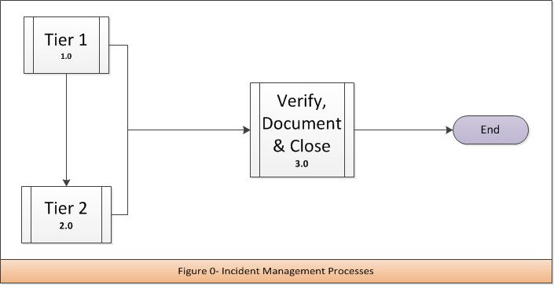

Incident Management High Level Process Descriptions
Activity | Description
1.0  Incident Management Tier 1 | This process describes the activities that take place to resolve incidents within the support center (Tier 1). Interactions which are determined to be anything other than an incident are outside the scope of this process.
2.0  Incident Management Tier 2 | Incidents that are unable to be resolved at Tier 1 are escalated to second level support (Tier 2).
3.0  Incident Management Verify, Document & Close (V,D & C) | This process is used by both Tier 1 and Tier 2 to ensure all incidents are verified, documented and closed consistently.

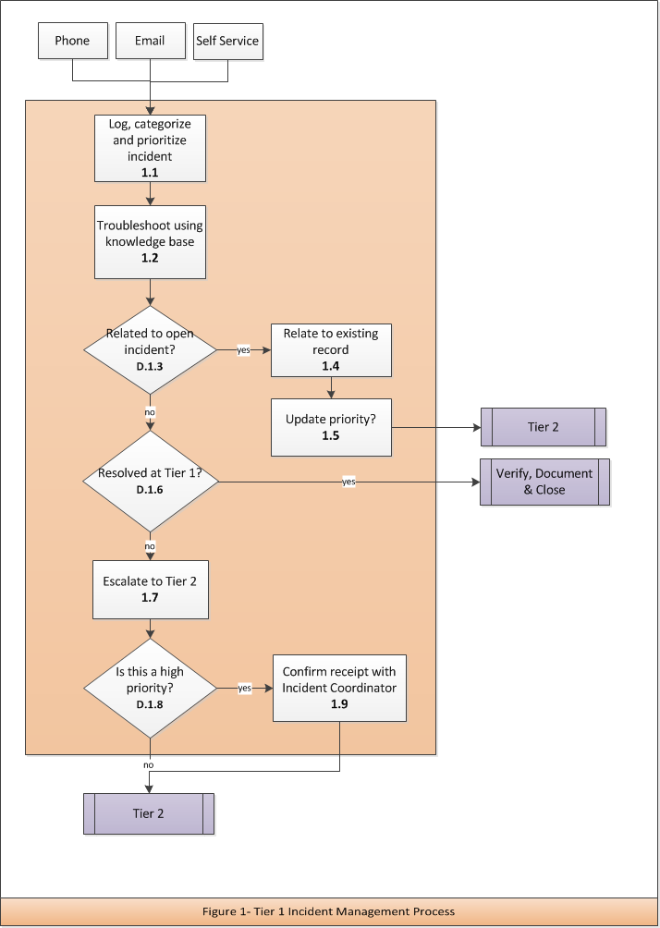Incident Management Tier 1 Process Activity Descriptions
1.1 | Log, Categorize and Prioritize Incident
Purpose | The incident is logged, prioritized, and categorized in the ITSM tool to enable tracking and monitoring through resolution of the incident
Requirement Statement | All incidents are tracked in the ITSM tool
Inputs | Phone, email, self service notification
Procedure or Work Instruction Steps | - Incident is logged in the ITSM tool  - Include incident details  - Incident is categorized based on internal agreement  - Incident is prioritized based on impact and severity  - Choose customer notification method
Outputs | Incident record
Metric | 1) Total number of incidents reported 2) Number of incidents by category 3) Number of incidents by priority

1.2 | Troubleshoot Using Knowledge Base
Purpose | Resolve incident quickly, minimizing impact to the university
Requirement Statement | To resolve incident at initial point of contact
Inputs | Incident record and available knowledge base articles
Procedure or Work Instruction Steps | - Has another customer called with a similar incident?  - Use available knowledge to resolve the incident  - Attempt to resolve the incident collaboratively with customer  - Attempt to resolve incident using remote assistance  - Apply resolution if applicable
Outputs | - Updated Incident record  - New or updated knowledge base record
Metric | - Time to resolve incident  - Incidents resolved using remote assistance  - Incidents resolved using knowledge base

D.1.3 | Related to Open Incident?
Purpose | Tier 1 combines similar service requests into one incident. The purpose of relating records is to minimize the impact to Tier 2 resources. Reference Support Center’s Escalated Records Dashboard (ERD).
Decision Logic | Yes – Go to 1.4 Relate to existing record  No – Go to D.1.6 Resolved at Tier 1?

1.4 | Relate to Existing Record
Purpose | To link similar incidents together under one parent incident record. When parent incident is closed, customers are notified based on notification method in step 1.1
Requirement Statement | All duplicate incidents will be relate to a parent record. Related service requests should be combined together to minimize the number of incidents being worked on.
Inputs | Incident record
Procedure or Work Instruction Steps | - Relate new incident to open incident using ITSM tool referencing ERD managed by Incident Manager  - If relationship error is made (not related appropriately or mis-assigned) first line support will break relation and modify parent/child relationships
Outputs | Updated Incident record
Metric | 1) Number of related requests to one incident 2) Number of incidents re-opened

1.5 | Update Priority
Purpose | Multiple reports of a similar incident may reflect a larger scope of service degradation. Incident resolution may require additional resources.
Requirement Statement | Incidents will have an assigned priority allowing appropriate resources to be directed towards resolution.
Inputs | Multiple incident records, ERD
Procedure or Work Instruction Steps | - Update priority of parent record  - Priority based on impact and severity  - Incident Manager communicates with the appropriate Incident Coordinator
Outputs | Updated incident record
Metric | Number of high priority incidents

D.1.6 | Resolved at Tier 1?
Purpose | Determine whether escalation is needed
Decision Logic | Yes – Go to VD&C process  No – Go to 1.7 Escalate to Tier 2

1.7 | Escalate to Tier 2
Purpose | To escalate incidents to the correct Tier 2 group based on established service agreements
Requirement Statement | Resolve all incidents at the lowest level possible
Inputs | Incident record
Procedure or Work Instruction Steps | - Validate completeness of incident record per established service agreements  - Reference service agreements to determine Tier 2 assignment group  - Support Center may act as Tier 2 in support of specific services  - Escalate incident
Outputs | Updated incident record
Metric | 1) Number of incidents escalated 2) Number of incidents resolved at Tier 1

D.1.8 | Is This a High Priority?
Purpose | High priority incidents require additional coordination with Tier 2 support
Decision Logic | Yes – Go to 1.9 Confirm receipt with Incident Coordinator  No – Go to Tier 2 process

1.9 | Confirm Receipt with Incident Coordinator
Purpose | Confirm Tier 2 is aware of a high priority incident ensuring resources are allocated to resolution in a timely manner
Requirement Statement | Incidents will have an assigned priority allowing appropriate resources to be directed towards resolution.
Inputs | Incident record
Procedure or Work Instruction Steps | - Tier 1 technician confirms the Tier 2 incident coordinator (or designee) received the incident record  - Tier 1 technician makes Tier 2 incident coordinator (or designee) aware of the high priority incident  - Tier 1 technician passes along incident details to the Tier 2 incident coordinator (or designee)
Outputs | Updated incident record
Metric | Number of incidents by priority

Incident Management Tier 1 Process RACI Matrix
Activity | IM Process Owner | Tier 1 Technician | Tier 2 Incident Coordinator | Tier 2 Technician | Customer
1.1  Log, categorize and prioritize incident | A | R |  |  | C
1.2  Troubleshoot using knowledge base | A | R
D.1.1  Related to open incident? | A | R
1.3  Relate to existing record | A | R
1.4  Update priority | A | R | C |  | I
D.1.2  Resolved at Tier 1? | A | R
1.5  Escalate to Tier 2 | A | R | I
D.1.3  Is this a high priority? | A | R
1.6  Confirm receipt with incident coordinator | A | R | C

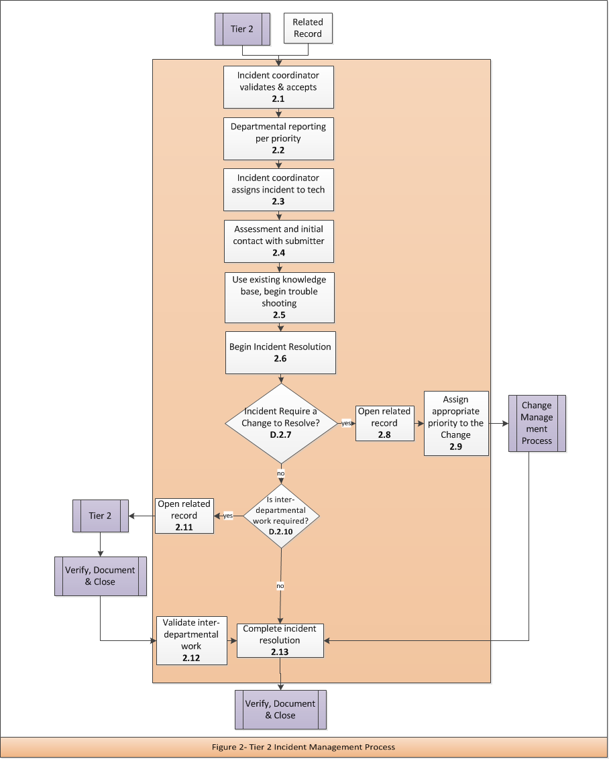

Incident Management Tier 2 Process Activity Descriptions
2.1 | Incident Coordinator Validates & Accepts
Purpose | Verify that incident is assigned correctly, correct priority, valid incident and acknowledged by assignment team
Requirement Statement | When validating Incidents, it is the responsibility of the Incident Coordinator to determine if the ticket is assigned, prioritized and categorized correctly.
Inputs | Incident Record  Related Record, Phone, Email, Alerts, Internal Service Request, Self Service
Procedure or Work Instruction Steps | - Incident Coordinator review Incident for accuracy  - Incident Coordinator verifies assignment  - Incident Coordinator acknowledges acceptance  - Update Incident Record
Outputs | Updated Incident Record
Metric | Number of records incorrectly assigned Incidents  Number of tickets by priority  Time to assignment

2.2 | Departmental Reporting Per Priority
Purpose | Depending on Departmental requirements, reporting requirements might be different for various priorities.
Requirement Statement | If special reporting is required, it will be done according to Departmental requirement
Inputs | Incident Record
Procedure or Work Instruction Steps | - Determine whether the priority of this ticket requires special reporting  - Follow procedures for special reporting
Outputs | Updated Incident Record
Metric | Number of tickets requiring special handling

2.3 | Incident Coordinator Assigns Incident to Tech
Purpose | The incident will be assigned to a technician to begin work
Requirement Statement | All incidents will be assigned to a technician to begin steps for resolution
Inputs | Incident Record
Procedure or Work Instruction Steps | - Incident Coordinator assigns Incident to technician
Outputs | Updated Incident Record

2.4 | Assessment and Initial Contact with Submitter
Purpose | To begin assessment of the Incident and contact submitter informing them that their request is being worked on
Requirement Statement | All incidents must be assessed to determine steps to resolution and the submitter of the related record will be contacted notifying them that work has begun
Inputs | Incident Record
Procedure or Work Instruction Steps | - Technician will make initial contact with the submitter to confirm that their Incident is being addressed and ask any preliminary questions that may be needed to troubleshoot  - Technician will conduct an initial assessment of the incident
Outputs | Updated Incident Record

2.5 | Use Existing Knowledge Base, Begin Troubleshooting
Purpose | Use existing knowledge base, if applicable, to begin troubleshooting
Requirement Statement | OIT / Departmental knowledge bases assist technicians with troubleshooting
Inputs | Incident Record
Procedure or Work Instruction Steps | - Technician will check the knowledgebase to see if there is information available on the Incident  - Technician will begin troubleshooting
Outputs | Updated Incident Record

2.6 | Begin Incident Resolution
Purpose | Incident Technician will take initial steps required to complete the Incident resolution
Requirement Statement | All Incidents must be resolved
Inputs | Incident Record
Procedure or Work Instruction Steps | - Incident Technician begins initial work required to resolve the incident  - If resolution requires assistance from a vendor or the acquisition and/or replacement of hardware:  - Set incident record status accordingly  - Annotate record with case, ticket, order or RMA number  - Notify submitter of possible delays
Outputs | Updated Incident Record

D.2.7 | Incident Require a Change to resolve?
Purpose | If a change is required to resolve the incident, a related Change record must be created.
Decision Logic | Yes – Go to 2.8 Open related record  No – Go to D.2.10 Is interdepartmental work required?

2.8 | Open Related Record
Purpose | To inform a department that a Change will be needed to resolve an Incident
Requirement Statement | If a Change is required to resolve an Incident, a related Change record is created to inform the department of the work they will need to complete
Inputs | Incident Record
Procedure or Work Instruction Steps | - Open a new/related Change record classified and prioritized appropriately  - If the new/related Change record is a high priority, confirm that the necessary department received the new/related record.
Outputs | Updated Incident Record and Change Record
Metric | Number of Incidents that require a Change to resolve

2.9 | Assign Appropriate Priority to the Change
Purpose | To ensure that the change record documents that it is required to resolve an incident
Requirement Statement | All changes related to the resolution of an Incident must have an associated priority
Inputs | Incident Record
Procedure or Work Instruction Steps | - Update the record to reflect that a Change is required to resolve the incident
Outputs | Updated related record

D.2.10 | Is Inter-Departmental work required?
Purpose | If another department is needed to resolve an Incident, the technician must create a related record. If yes, go to 2.8. If no, go to D.2.11
Decision Logic | Yes – Go to 2.11 Open related record  No – Go to 2.13 Complete Incident resolution

2.11 | Open Related Record
Purpose | To inform another department that they will be involved in the resolution of an Incident
Requirement Statement | If inter-departmental work is required, a related record is created to inform that department of the work they will need to complete
Inputs | Incident Record
Procedure or Work Instruction Steps | - Open a new/related Incident record classified and prioritized appropriately  - If the new/related Incident record is a high priority, confirm that the necessary department received the new/related Incident record.
Outputs | Updated Incident Record

2.12 | Validate Related Work
Purpose | After related work is completed, either as a Change, another Incident or both, tasks will be confirmed by the department that created the related record
Requirement Statement | If a department creates a related record, all tasks completed by another department must be validated
Inputs | Incident Record
Procedure or Work Instruction Steps | - Ensure all related record have been closed and are validated
Outputs | Updated Incident Record

2.13 | Complete Incident Resolution
Purpose | Incident Technician will take final steps required to complete the Incident resolution
Requirement Statement | All Incidents must be resolved
Inputs | Incident Record
Procedure or Work Instruction Steps | - Incident Technician completes all work required to finalize resolution
Outputs | Updated Incident Record

Incident Management Tier 2 Process RACI Matrix
Activity | IM Process Owner | Tier 1 Technician | Tier 2 Incident Coordinator | Tier 2 Technician | Customer
2.1 Incident Coordinator Validates & Accepts | A |  | R
2.2 Departmental Reporting Per Priority | A |  | R | R
2.3 Incident Coordinator Assigns Incident to Tech | A |  | R | C/I
2.4 Assessment and Initial Contact with Submitter | A |  |  | R | C
2.5 Use Existing Knowledge base, Begin Troubleshooting | A |  |  | R
2.6 Begin Incident Resolution | A |  |  | R | C/I
D.2.7 Incident Require a Change to Resolve? | A |  | C/I | R
2.8 Open Related Record | A |  |  | R | I
2.9 Assign Appropriate Priority to the Change | A |  |  | R
D.2.10 Is inter-departmental work required? | A |  | C/I | R
2.11 Open Related Record | A |  |  | R | I
2.12 Validate related work | A |  |  | R
2.13 Complete Incident Resolution | A |  | I | R | C/I

H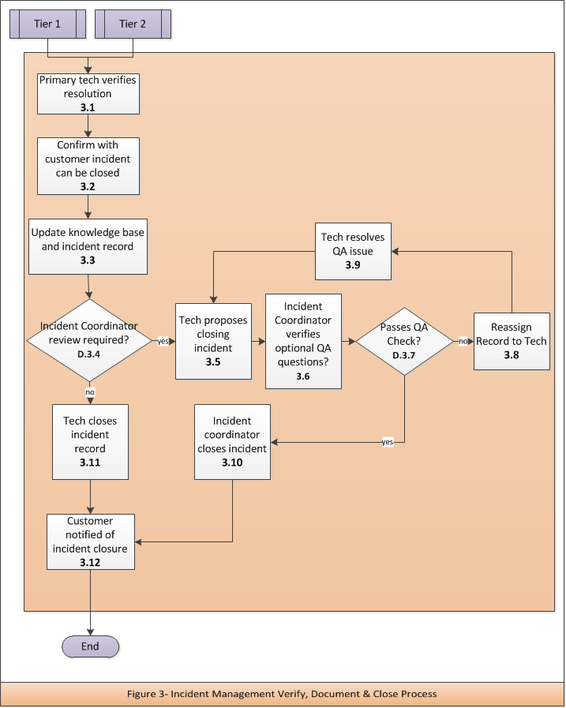

Incident Management Verify, Document & Close Process Activity Descriptions
3.1 | Primary Tech Verifies Resolution
Purpose | Verification of incident resolution with the customer
Requirement Statement | Keeping with high standards of customer service, the tech must verify that the resolution applied fixed the issues the customer was experiencing
Inputs | Incident record (specifically the resolution)
Procedure or Work Instruction Steps | - Tech verifies fix applied, resolves issue from tech’s end  - Tech will contact the customer  - Tech confirms from customer’s perspective that the resolution applied fixed the issue that caused them to submit a ticket
Outputs | Customer verification that the resolution fixed their issue
Metric | Length of time to resolution

3.2 | Confirm with Customer Incident can be Closed
Purpose | Validation and confirmation of incident resolution with the customer
Requirement Statement | Keeping with high standards of customer service, the tech must confirm that the customer is comfortable with closing their ticket because their issue has been resolved.
Inputs | Conversation with the customer
Procedure or Work Instruction Steps | - After contacting the customer via prefered method to verify that the applied resolution worked, confirm with the customer that the incident record is able to be closed.
Outputs | Customer validates that it is alright to close their record. If not, the record must be routed through the Tier2 process again.
Metric | Length of time to closure

3.3 | Update Knowledge Base and Incident Record
Purpose | Update the knowledge base accessed by your department or by OIT, whichever applies.
Requirement Statement | Sharing knowledge of incidents occurring throughout campus is a helpful tool when detecting root causes. Whether a departmental knowledge base or one knowledge base for all of OIT, the knowledge base must be updated to assist others using the ITSM tool.
Inputs | Steps to resolution
Procedure or Work Instruction Steps | - Update Incident Record with actions taken for 3.1 and customer responses in 3.2 as well as any other responses that apply to the resolution of the incident  - Update relevant Knowledge Base
Outputs | Updated Incident Record and Knowledge Base

D.3.4 | Is Review Required by the Incident Coordinator?
Purpose | To provide a “second pair of eyes,” for additional Quality Assurance at the departmental level.
Decision Logic | Yes – Go to 3.5 Tech proposes closing Incident  No – Go to 3.11 Tech closes Incident record

3.5 | Tech Proposes Closing Incident
Purpose | If additional Quality Assurance check is required, another technician will verify the work that was completed
Requirement Statement | The technician believes that the incident was resolved and submits the incident record to management or the Incident Coordinator for review that it meets departmental standards and adheres to procedures
Inputs | The Incident Record
Procedure or Work Instruction Steps | - Tech changes status to pending closed  - Submits the incident record for review to management or Incident Coordinator
Outputs | Updated Incident Record
Metric | Number of additional Quality Assurance reviews by department.

3.6 | Incident Coordinator Verifies Optional QA Questions
Purpose | Provides a second opportunity to ensure that the technician completed the required steps
Requirement Statement | Some departments may deem it necessary to use an additional quality assurance steps. If so, ensure affirmative or appropriate context is provided in the incident record.
Inputs | Incident Record
Procedure or Work Instruction Steps | Here are some examples of quality assurance questions:  - What were the steps completed to resolve the Incident?  - Did the technician test the resolution?  - Did the customer test the resolution?  - Did the customer verify that the Incident Record can be closed?  - What Knowledge Base article was used?
Outputs | Updated Incident Record
Metric | Number of Incidents that fail QA Check

D.3.7 | Passes QA Check?
Purpose | It is the responsibility of the Incident Coordinator to determine whether the incident passes the QA Check. If yes, go to 3.10- Incident Coordinator Closes Incident. If no, go to 3.8-Reassign Record to Tech.
Decision Logic | Yes – Go to 3.10 Incident Coordinator closes Incident  No – Go to 3.8 Reassign record to tech

3.8 | Reassign Record to Tech
Purpose | Assign to Technician to resolve outstanding QA Issues
Requirement Statement | It is the responsibility of the Incident Coordinator to assign the incident to a technician to resolve all outstanding issues
Inputs | Incident Record
Procedure or Work Instruction Steps | - Incident Coordinator assigns Incident Record to technician  - Incident coordinator communicates needed information to be included in the incident records or appropriate changes to bring resolution into compliance with QA
Outputs | Updated Incident Record
Metric | Number of Incidents Failing Quality Assurance Check

3.9 | Tech Resolves QA Issue
Purpose | Technician to resolve outstanding QA Issues
Requirement Statement | In order to pass a QA check, the technician ensures that all standard operating procedures have been met
Inputs | Incident Record
Procedure or Work Instruction Steps | - Technician resolves all outstanding QA issues  - Resubmit record to Incident Coordinator, step 3.5
Outputs | Updated Incident Record

3.10 | Incident Coordinator Closes Incident
Purpose | Incident passed the QA check enabling the Incident Coordinator to close the record
Requirement Statement | All Incident Records will be closed upon completion
Inputs | Incident Record
Procedure or Work Instruction Steps | - Incident Coordinator changes the status of the record to closed
Outputs | Closed Incident Record

3.11 | Tech Closes Incident Record
Purpose | If no Quality Assurance check was needed, the technician closes the incident record
Requirement Statement | All Incident Records will be closed upon completion
Inputs | Incident Record
Procedure or Work Instruction Steps | - Technician changes the status of the record to closed
Outputs | Closed Incident Record

3.12 | Customer Notified of Incident Closure
Purpose | The customer must be notified that their Incident has been closed in the ITSM tool
Requirement Statement | All customers must be notified when their Incident Record has been closed in the ITSM tool
Inputs | Closed Incident Record
Procedure or Work Instruction Steps | - Customer is notified based upon their notification preference  - If preference is email then automated email generated from the ITSM tool is sufficient  - If preference is telephone, the Support Center is notified and will follow up with the customer via telephone
Outputs | Customer Notification of closure

Incident Management Verify, Document & Close Process RACI Matrix
Activity | IM Process Owner | Tier 1 Technician | Tier 2 Incident Coordinator | Tier 2 Technician | Customer
3.1 Primary Tech Verifies Resolution | A | R |  | R | C
3.2 Confirm with Customer Incident can be Closed | A | R |  | R | C
3.3 Update Knowledge base and Incident Record | A | R | C | R
D.3.4 Is Additional Incident Coordinator Review Required? | A | R | R | R
3.5 Technician Proposes Closing Incident | A | R |  | R
3.6 Incident Coordinator Verifies Optional QA Questions | A | C | R | C
D.3.7 Passes QA Check? | A |  | R
3.8 Reassign Record to Technician | A | I | R | I
3.9 Tech Resolves QA Issue | A | R | C | R | C
3.10 Incident Coordinator Closes Incident | A |  | R
3.11 Technician Closes Incident Record | A | R |  | R
3.12 Customer Notified of Incident Closure | A | R |  |  | I

