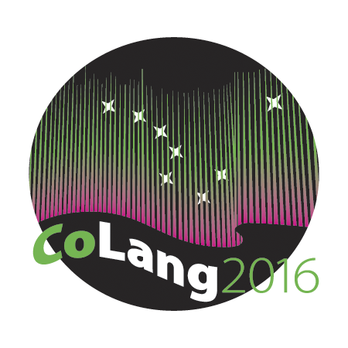

Colang 2016 Workshop Syllabus

- Title:
Documentation of Orature.

- Instructors’ names and email:
- Imelda Icheji Lawrence Udoh icheji@gmail.com
- Uwemedimo Enobong Iwoketok uiwoketok@yahoo.com

- Introduction:
Orature is an amalgamation of two words: oral and literature. It depicts the creative impulse of the society it evolves from. This artistic expression includes proverbs, riddles, extemporized poems/songs, folktales, childlore, etc. The general observation is that attention has been given to aspects of Orature by adults almost to the exclusion of children’s artistic expression. There is no doubt that some aspects of our collective Orature has been put in print. However, much more is yet to be documented. It is also often not considered that both adults and children draw their experiences from the same setting, they employ the same language and discuss the same socio-cultural issues; they express the same hopes and aspirations. In fact adults very quickly forget that they were once children as they quite often look down on childhood tradition. On the other hand, how quickly their faces radiate with nostalgic laughter/smile as they recall some of the childhood games they played. For a holistic documentation therefore, it is necessary that the artistic creation of adults together with those of children should be collected, collated, analysed and properly documented either for revitalization or for archiving.

- Course materials:
- Gibbert, J. Himmelmann, N. P. Mosel, U. 2006. Essentials of language documentation. Berlin: Mouton de Gruyter
- Akporobaro, F. B. O. 2005. Introduction to African Oral Literature. Ikeja: Princeton Publishing Co.
- Finnegan, Ruth. 1984. Oral Literature in Africa, Nairobi: Oxford University Press.
- Okpewho, Isidore, 1990. The Oral Performance in Africa, Ibadan: Spectrum Books Limited.
- Cameron, Elizabeth L. and Ross, Doran H. 1996. Isn’t S/he a Doll? Hong Kong: South Sea International Press Ltd.
- Sutton-Smith, Brian, Meching, Jay, Johnson, Thomas W. and McMahon, Felicia R. (eds). 1995. Children’s Folklore: A Source Book, New York and London: Garland Publishing Inc.

- Supplies needed:
- Sony handy cam (video camera)
- Zoom audio recorder
- Some songs for children and by children
- Some traditional toys by/for children

- Course goals:
- To equip participants with the skills for the documentation of the different genres in Orature
- To equip participants with the skills for the analysis of the different genres on oral lore performance;
- Relate Orature to contemporary realities and issues.
.
- Student learning objectives:
- To learn skills and acquire knowledge for the documentation of Orature;
- To learn the skills and acquire knowledge on the analysis of Orature;
- To stem the tide of death of aspects of a people’s endangered cultural traditions;
- To appreciate the acculturation associated with Orature;
- To acquire new knowledge of Orature as an Indigenous Knowledge Systems.

- Instructional methods:
We shall adopt the 5Es Instructional Model with a learner-centered approach, especially as the content of the workshop may be strange to some of the students. This model involves engagement, exploration, explanation, elaboration and evaluation in the interaction between the instructors and the students. The workshop will involve the following:
- a mental engagement of the students with events, questions and some engagement activities to help them connect with the content of aspects of the Orature that would be strange to them;
- group work by students to explore ideas on the data that will be provided through hands-on and minds-on activities with the instructors guide to facilitate their understanding of major concepts, skills and acculturation associated to Orature;
- clarification and explanation by instructors to aid students’ understanding and introduction of new concepts regarding folklore;
- the students will be challenged to apply what they learnt and build on them.
- the students’ knowledge, skills and abilities will be assessed to allow for evaluation (see I below).

- Evaluation:
This workshop will involve a grasp of a set of knowledge pieces and skills, in a learning progression. This will be checked at points with different kinds of questions and assignments designed to test both knowledge and skill acquisition.

Workshops will be Pass/Fail: Full attendance is required for a pass.

The students will present a mini-project at the end of the workshop on one of the following:
- create a piece in one of the genres – prose, poetry, drama;
- document a tale from a culture you are familiar with for the purpose of revitalization of the culture and literacy.
Since the focus of documentation is preservation of language and culture under threat of extinction, students’ data and the analysis of same should serve for evaluation.

The following parameters will be used for evaluation:
- methodology;
- content;
- genre structure (stick to the rules, no literary license);
- creativity.

- Disabilities services:
“The Office of Disability Services implements the Americans with Disabilities Act (ADA), and insures that UAF students have equal access to the campus and course materials. The instructor will work with the Office of Disabilities Services (208 WHIT, 474-5655) to provide reasonable accommodation to students with disabilities.”

